Homework 4 TCP/IP

A file is being transferred between two computers across a network.

- Identify a protocol that could be used to transfer this file [1]

- The network uses TCP/IP as shown below
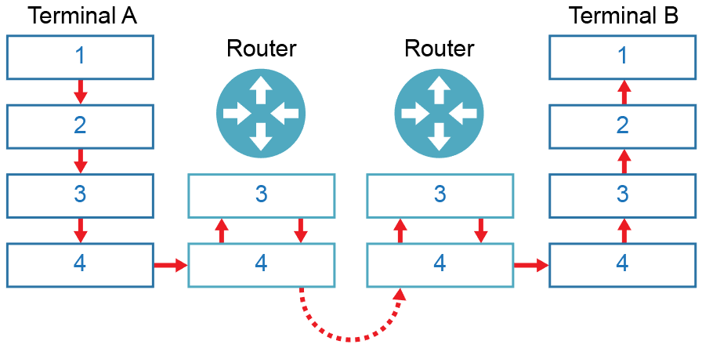
The numbers represent the layers of the TCP/IP stack. Name the layers
in the table below: [4]
Label | Layer
1
2
3
4

- Data packets travel from router to router on layers 3 and 4. As this happens, their headers change. Explain the changes with reference to IP and MAC addresses. [5]

A self-employed accountant runs his own business from a small office. He has an email server that he uses to communicate with his clients. A firewall is also used.

- Identify one protocol and its associated port that he can use to read email
held on this server. [2]

- The accountant also uses his smartphone to access emails. He finds that emails he reads in the office do not appear on his phone. Explain why this is. [2]

- A section of the company firewall log is displayed on the accountant’s computer.

Firewall blocked access to resource at 84.134.4.128:80
Firewall granted access to resource at 84.134.4.128:22

From the log above, give an example of the following:
- Port number [1]

- IP Address [1]

- Socket [1]

- Firewall settings currently restrict access to HTTP. Describe how Secure Shell could be used to circumvent this restriction and provide additional security.
Your answer should include what makes SSH a secure connection. [3]

[Total 20 Marks]

