Worksheet 5 IP addresses

Task 1

- Open up the spreadsheet IP Addresses Blank.xlsx

- Use an appropriate formula that can be used to automatically determine the network and host IDs of a given IP address
Hint: Use the AND, OR or NOT spreadsheet functions to replicate a bitwise operation to evaluate the each bit of the network and host IDs. Multiply a TRUE of FALSE output by 1 to convert it to a 1 or 0.
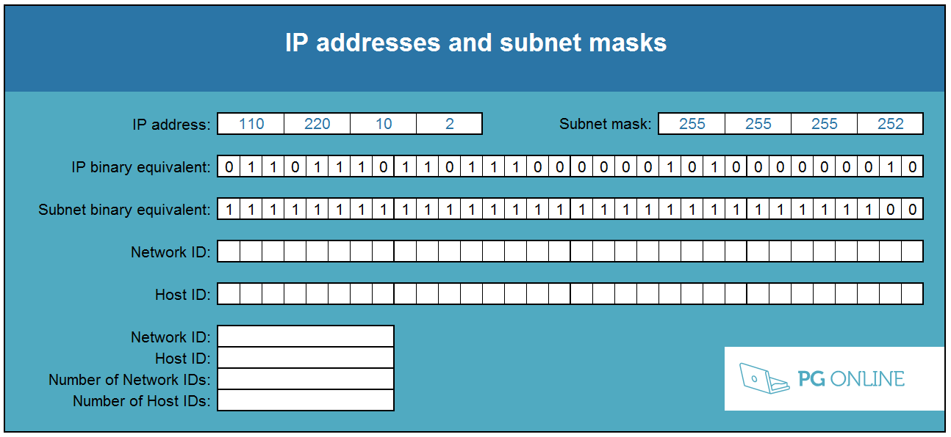

- Use the spreadsheet to complete the following table: (A complete spreadsheet is available called IP Addresses Complete.xlsx.)

IP Address | Subnet mask | Network ID | Host ID | Number of network IDs for this subnet mask | Number of host IDs for this subnet mask
110.220.10.2 | 255.255.255.252
10.2.5.19 | 255.0.0.0
253.63.48.99 | 255.255.0.0
33.66.99.11 | 255.255.255.128
33.66.99.240 | 255.255.255.128
48.65.195.253 | 255.192.0.0

- What is the relationship between the number of network IDs and the number of
host IDs?

Task 2

- Design the IP address scheme for a private network for a university campus that has five different buildings. Each building needs its own subnet with at least 1000 IP addresses available.

The network manager has decided that subnet IDs should be within the range 192.168.0.0 to 192.168.19.254.

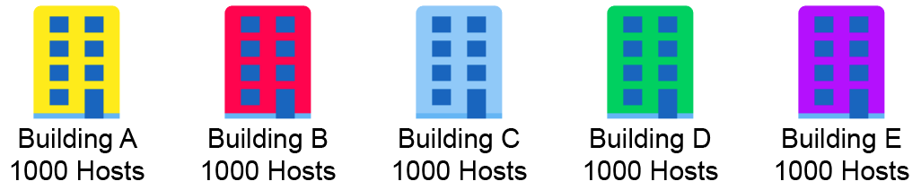
Network ID: | Network ID: | Network ID: | Network ID: | Network ID:
Subnet mask: | Subnet mask: | Subnet mask: | Subnet mask: | Subnet mask:

- What are the advantages of subnetting a network like this?

Task 3

- The subnets in Task 2 are connected via a network of routers. What additional network setting will be needed on each host so that machines in one building can communicate with another?

- Explain why this is needed within the context of subnets.

- The first two octets of the IP range used are 192.168. Explain why this is.

- The network of routers also includes a connection to the Internet. Explain, giving examples, how NAT will allow hosts on the network to access websites on the Internet.

