Name: Class:

Task 1
Explain how critical assessment contributes positively in the creation of new product solutions.

Task 2
Study the image of the sports shaker bottle below.
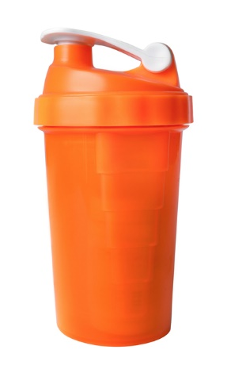
Analyse the sports shaker bottle considering the following points: aesthetics, ergonomics, function, materials and manufacturing processes.
Aesthetics:

Ergonomics:

Function:

Materials:

Manufacturing Processes:

Task 3
What is meant by the term ‘fitness for purpose’?

Name three key features that must a specification have.

Task 4
Study the image of the door handle below.
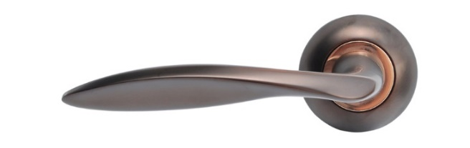
This product has been designed with ergonomics in mind. Explain how the designer has sought to meet the requirements of the client in designing and making this handle.

Task 5
Explain two advantages and two disadvantages of using 3D polymer printing to manufacture the working prototype in the image below.
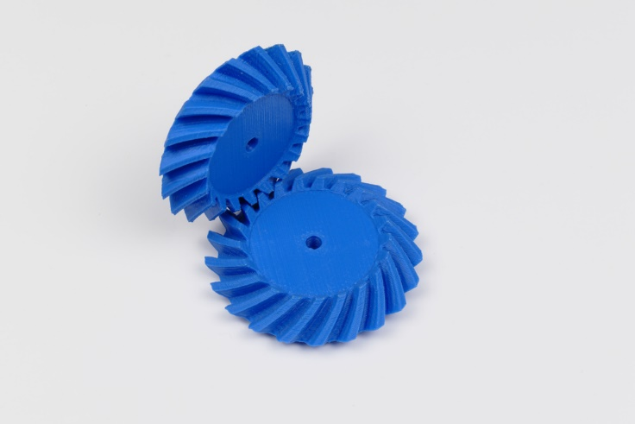

Advantages

Disadvantages

Task 6
Under the following headings, consider how manufacturers can ensure accuracy and efficiency during production.
Planning and preparation:

Processing:

