Name: Class:

Task A
Sort the following costs into direct and indirect costs using the grid below.
- Rent  - Depreciation of machinery  - Cost of tooling and dies  - Materials required for product  - Buildings insurance | - Energy bills  - Salaries of administrative staff  - Office supplies  - Labour costs of making the product
Direct costs | Indirect costs

Task 2
Study the shoe rack below.
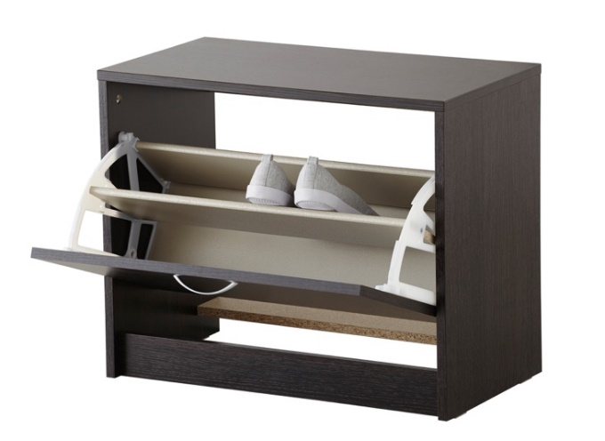
A manufacturer estimates the material and manufacturing cost for each unit will be £4.50 and that each unit will take 15 minutes to make. Two members of staff are required to make the product, working at £12.30/hour.
Calculate the total costs of making each unit including labour costs.

To inform the production plan, the feasibility study assesses two different scenarios to estimate a reasonable contingency fund.
Scenario A
Delays add 10 minutes to manufacturing time per unit. How much money will need to be added to the contingency fund to cover labour costs, if 250 units are required in total?

Scenario B
To beat a competitor to market, the manufacturing deadline has been brought forward. Staff need to work 85 hours extra each to meet the new deadline and must be paid overtime which is 50% more than their usual hourly rate. How much money would be added to the contingency fund to cover labour costs in this scenario?

Task 3
In recent years, there has been considerable research into the development of electric and hybrid vehicles such as the design proposal pictured below.

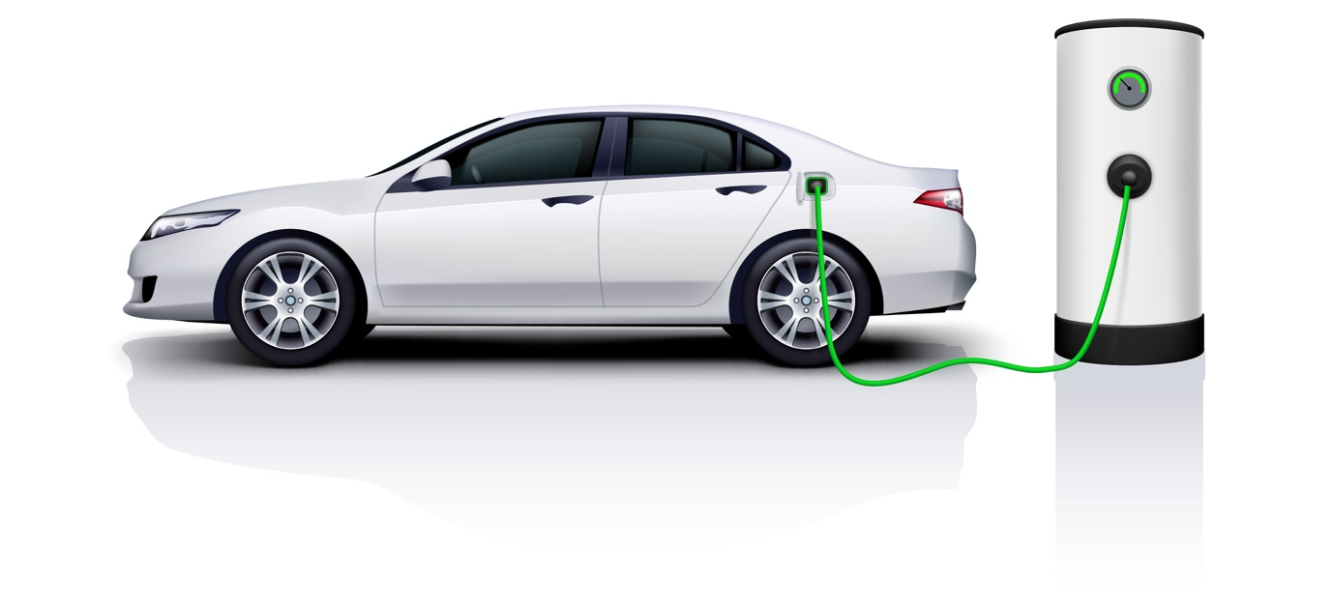
Study the SWOT analysis for the design and manufacture of the proposed vehicle above.
Strengths  - Makes use of recently developed existing technology  - Use of lightweight materials that exist already in automotive design  - Current legislation means road tax costs low  - Increasing demand for such a product  - More environmentally friendly than conventional cars | Weaknesses  - Expertise in the existing design team is lacking  - Retooling required for manufacture  - Extensive investment in new technology required  - Rapid development in technology in this area - product may become obsolete quickly  - Retail price for new electric vehicles is high compared to conventional cars
Opportunities  - Reduce pollution, particularly in cities  - Reduce consumption of fossil fuels  - Legislation is becoming stricter in terms of the use of conventional vehicles e.g. low emission zones  - A celebrity is interested in endorsing the product | Threats  - Lack of infrastructure to support recharging  - Road safety - cars are difficult to hear on approach  - Competitors are developing similar ideas  - New trade laws may cause delays to parts supplied from other countries
If the weaknesses and threats above were highlighted in a feasibility study, what actions could you take to reduce the risks and increase the chances of success prior to production? You may wish to discuss your thoughts and work in pairs.

Weaknesses

Threats

Task 4
Watch the Link video on Sursgibox – a portable operating theatre which would provide a sterile environment for operating on patients in disaster zones.
The proposed product is to be discussed in a focus group. What kinds of people would be part of the focus group and what would you hope to find out from them? Explain your response.

