Name: Class:

Task 1
Study the coffee machine below.
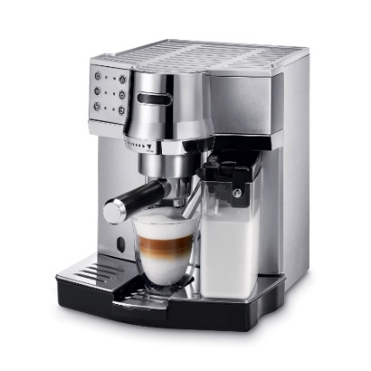
Complete and add to the mind map below to show the characteristics that might identify the customer group.

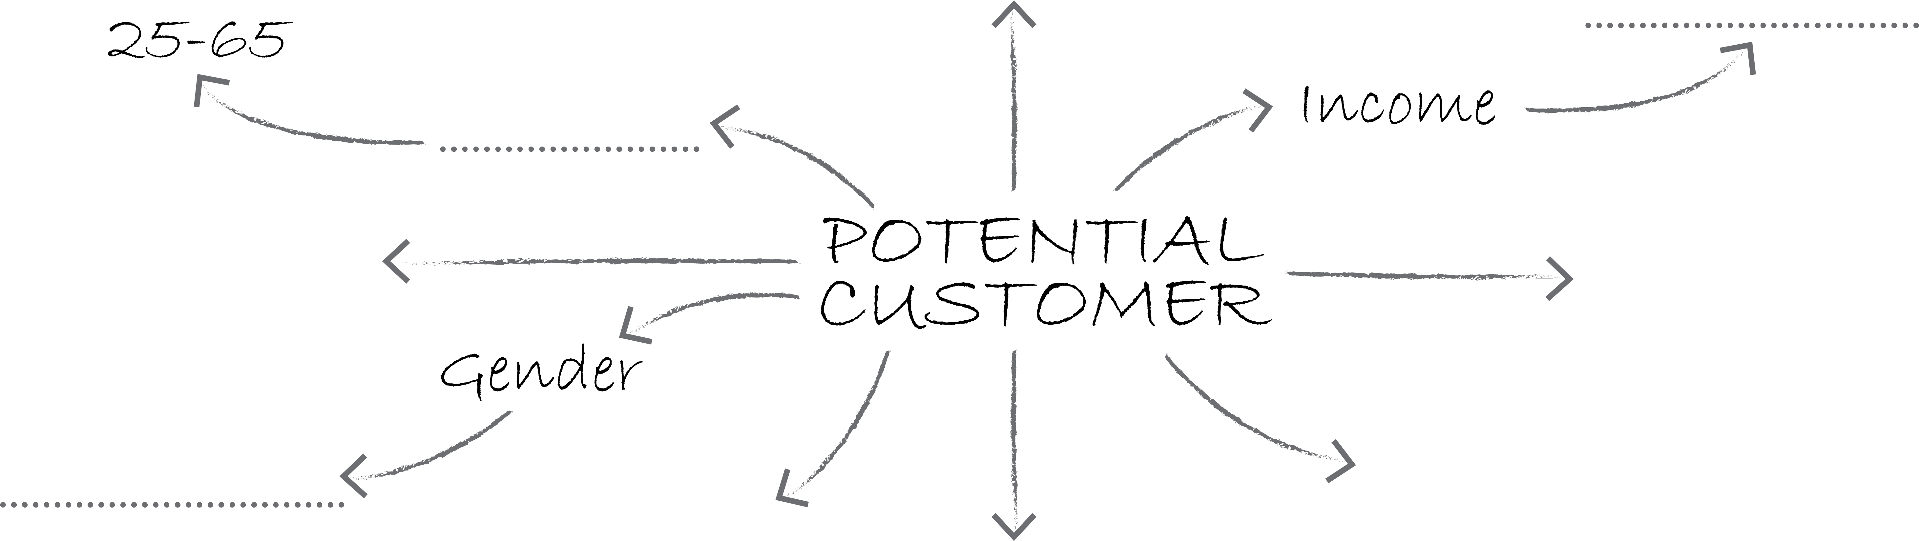
How might a consumer group with the following characteristics, inform design decisions when creating a new corporate identity? Refer to the following in your response:
- Name – colour – font – form

Consumer Identity |  | Branding decisions
Age | 18 – 35
Gender | Female
Hobbies | Socialising, blogging, fashion
Occupation | Professional / Business
Task 2
In pairs, give details of a marketing strategy to increase sales of the coffee machine in the space below.

Task 3
Use the scenario below to calculate the cost price for a new packaging design for a compact vacuum cleaner.
Once the machines for packaging production are set up, they produce 1,800 nets per hour.
Number of nets per sheet: 2
Corrugated card sheet (1000mm x 1200mm): 42p per sheet
Three technicians are required to keep production running and they are paid £15/hour
One-off set up costs | Print plate costs: | £200
One-off set up costs | Die cutting costs: | £2,500
One-off set up costs | Machine set up costs: | £400
One-off set up costs | Labour costs for initial set-up | £90
Running costs | Labour costs per hour
Running costs | Material costs per hour
Running costs | Cost of consumables (ink and glue)  per hour | £130
Running costs | Energy costs per hour | £15
Fill in the missing figures on the grid.
Calculate the unit cost for a production run of 1,250,000 units (assume production can run 24/7): Round costs to the nearest whole pence during your calculations.

