Name: Class: Mark:

1. When using a pie chart what is the angle of the segment that represents 1%? [1]

2. Which one of the following best describes a pie chart? [1]
⬨ A chart that compares two factors
⬨ A chart that shows area
⬨ A chart that shows growth
- A chart that shows proportions
3. Study the graphs below. Explain which orientation you would use to display the
profits of a company on a month by month basis. [2]
Graph A: Vertical orientation | Graph B: Horizontal orientation
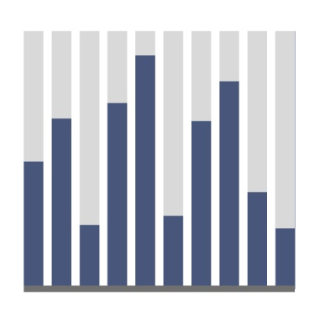

4. Explain one advantage of using a table to record customers’ personal details. [2]

5. Discuss the advantages and disadvantages of visualising data in charts and graphs compared to a written report. [8]

[Total 14 marks]

