Name: Class:

Starter
Use the mind map below to show as many techniques for communicating data that you
can think of.

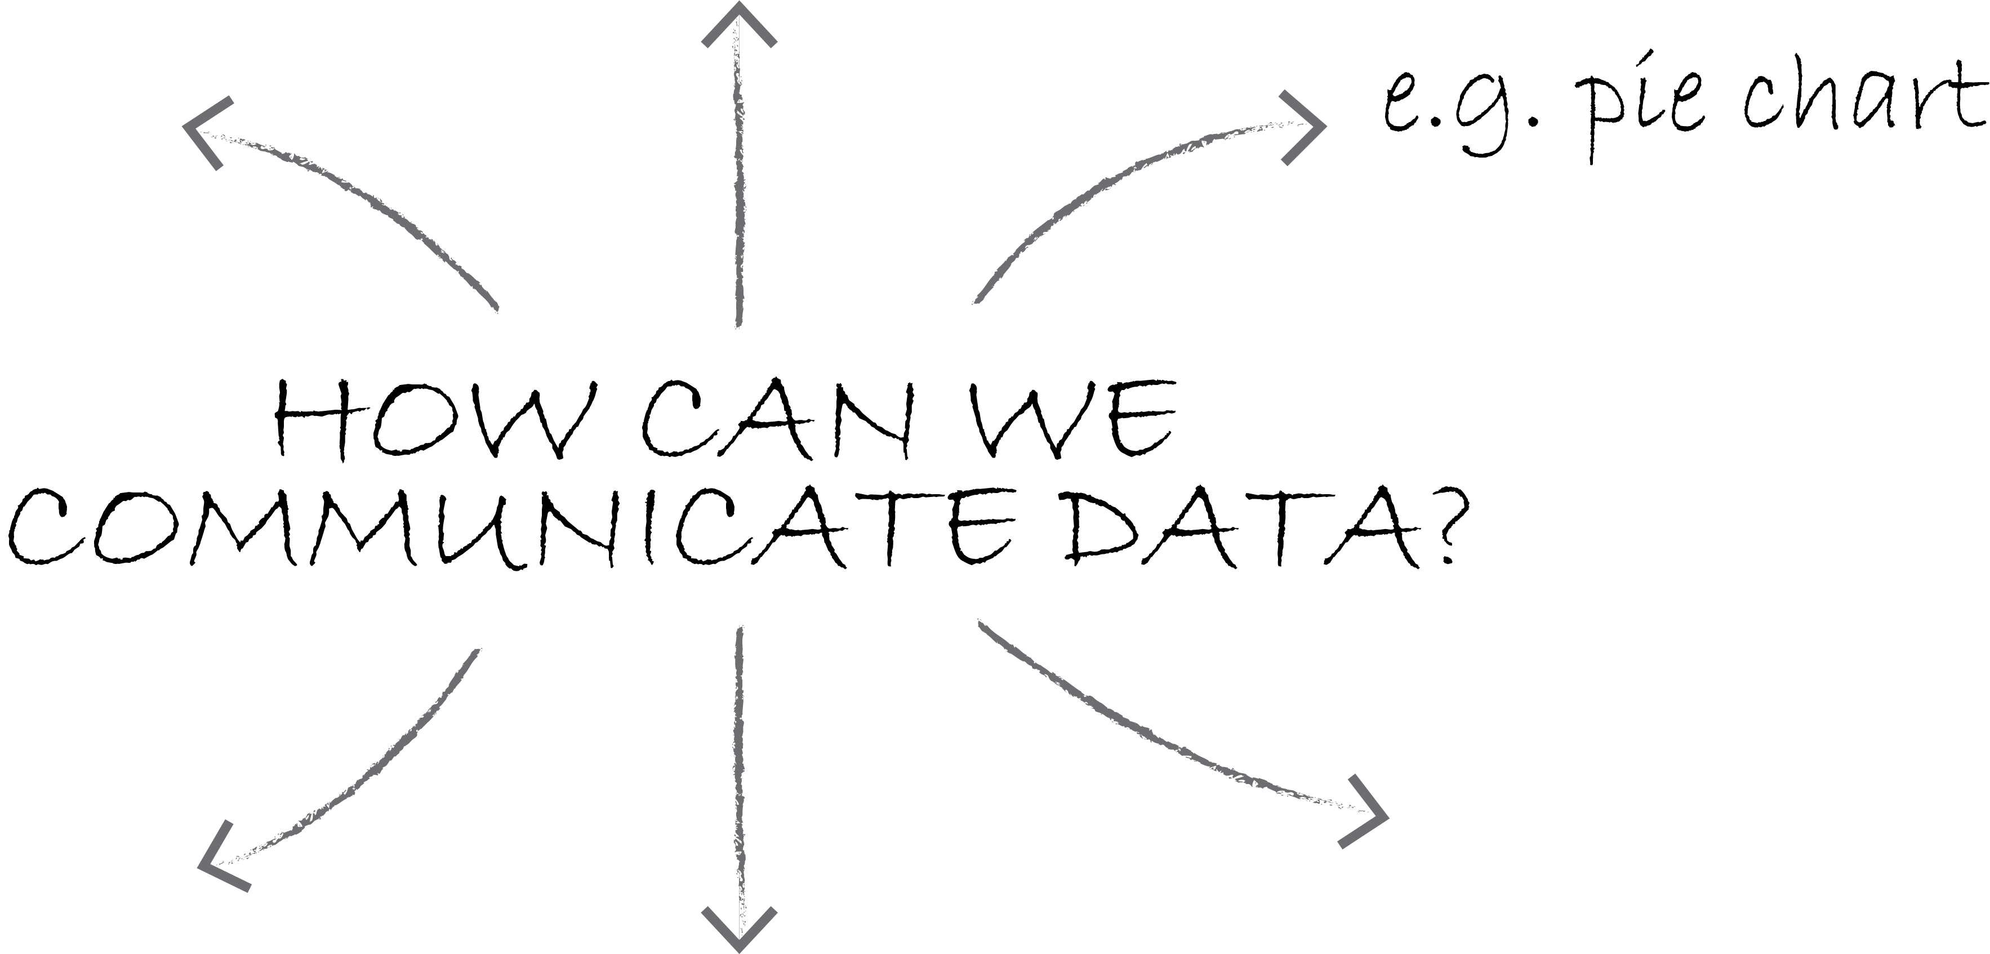

Circle all the techniques in the mind map that would be most suited to communicating quantitative data.

Task 1
Imagine you work for a start-up company looking for investors to back a new bin which allows users to separate their household waste more easily. Use the data below to create a 100-word (max) summary to describe the data and persuade the reader to invest in your product.
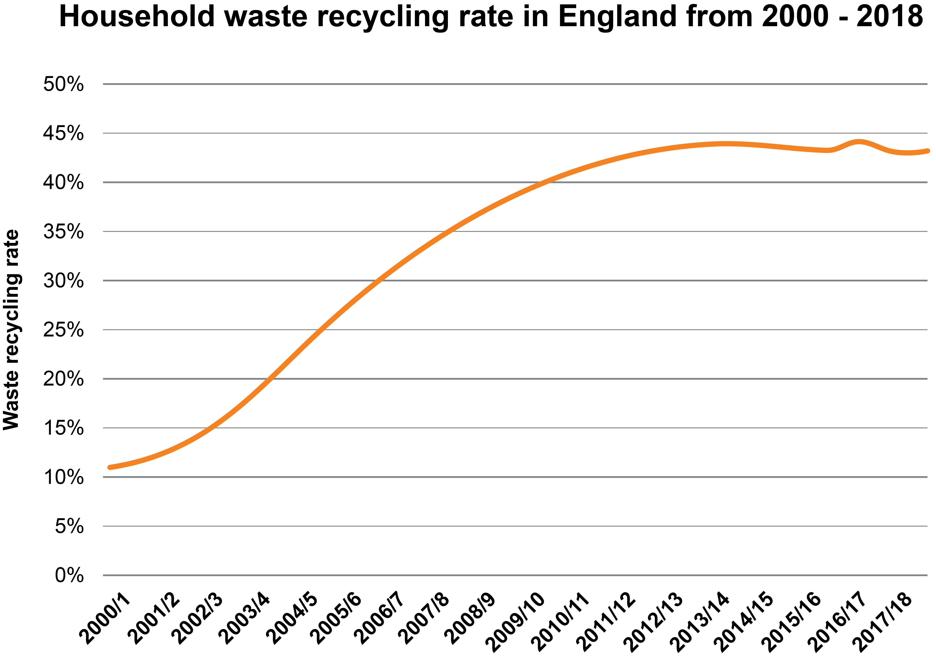

Task 2
Study the graphs and charts below. State which of the two charts is a fairer representation of the data and explain how the data has been manipulated to mislead the reader.
Chart to show levels of efficiency in different teams on a production line
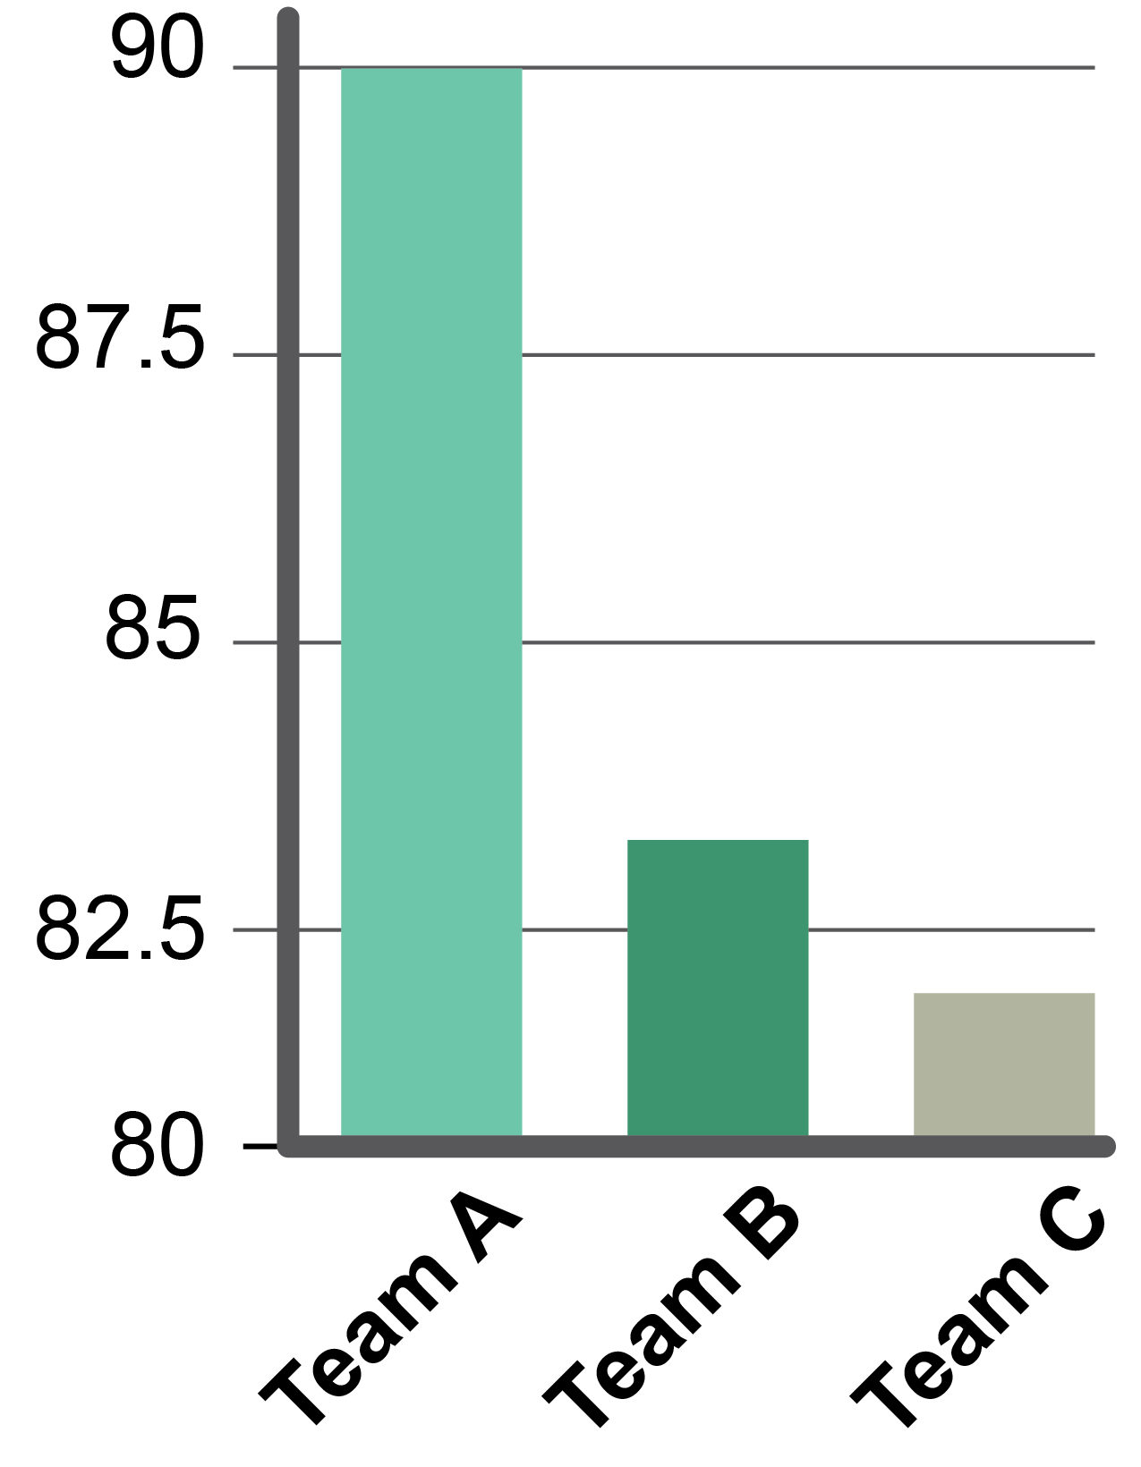 | 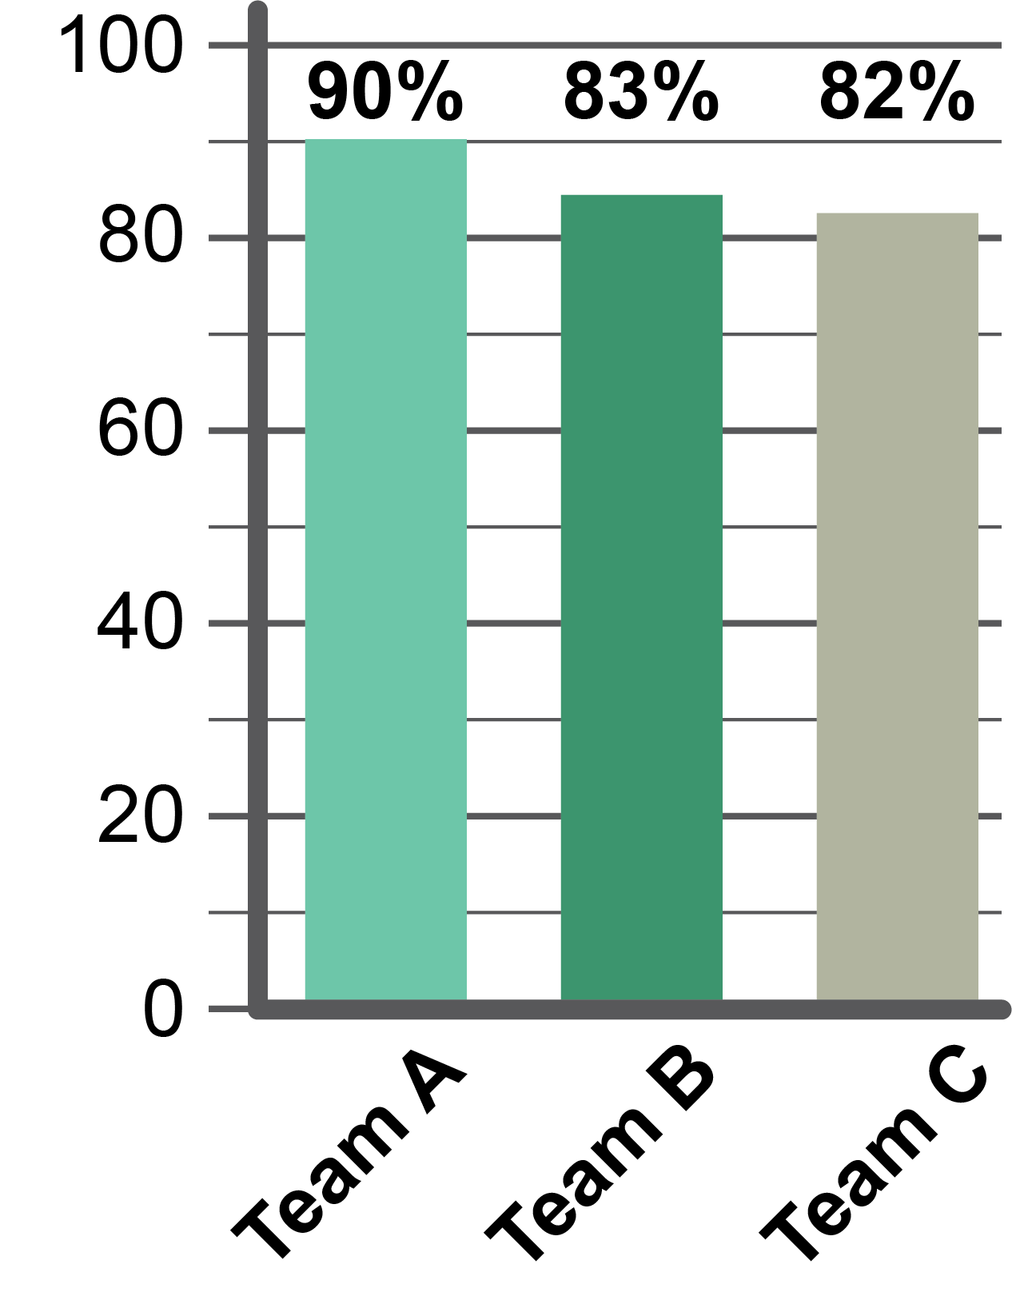
Chart A | Chart B
Chart to show company profits year on year
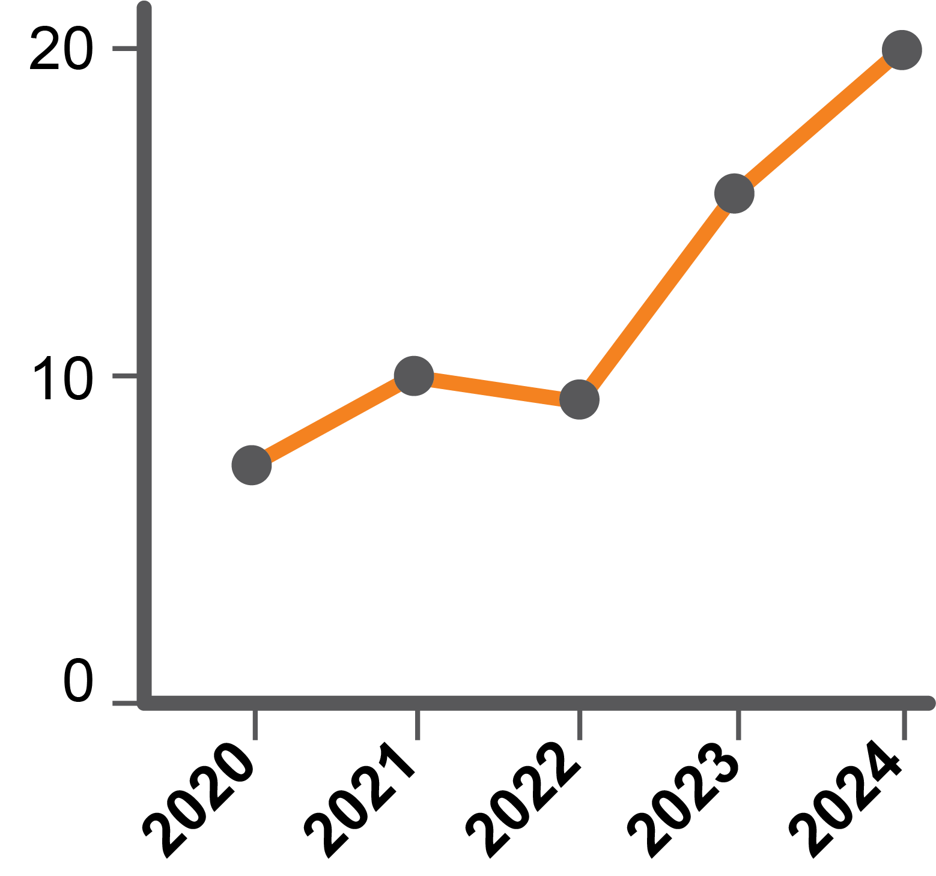 | 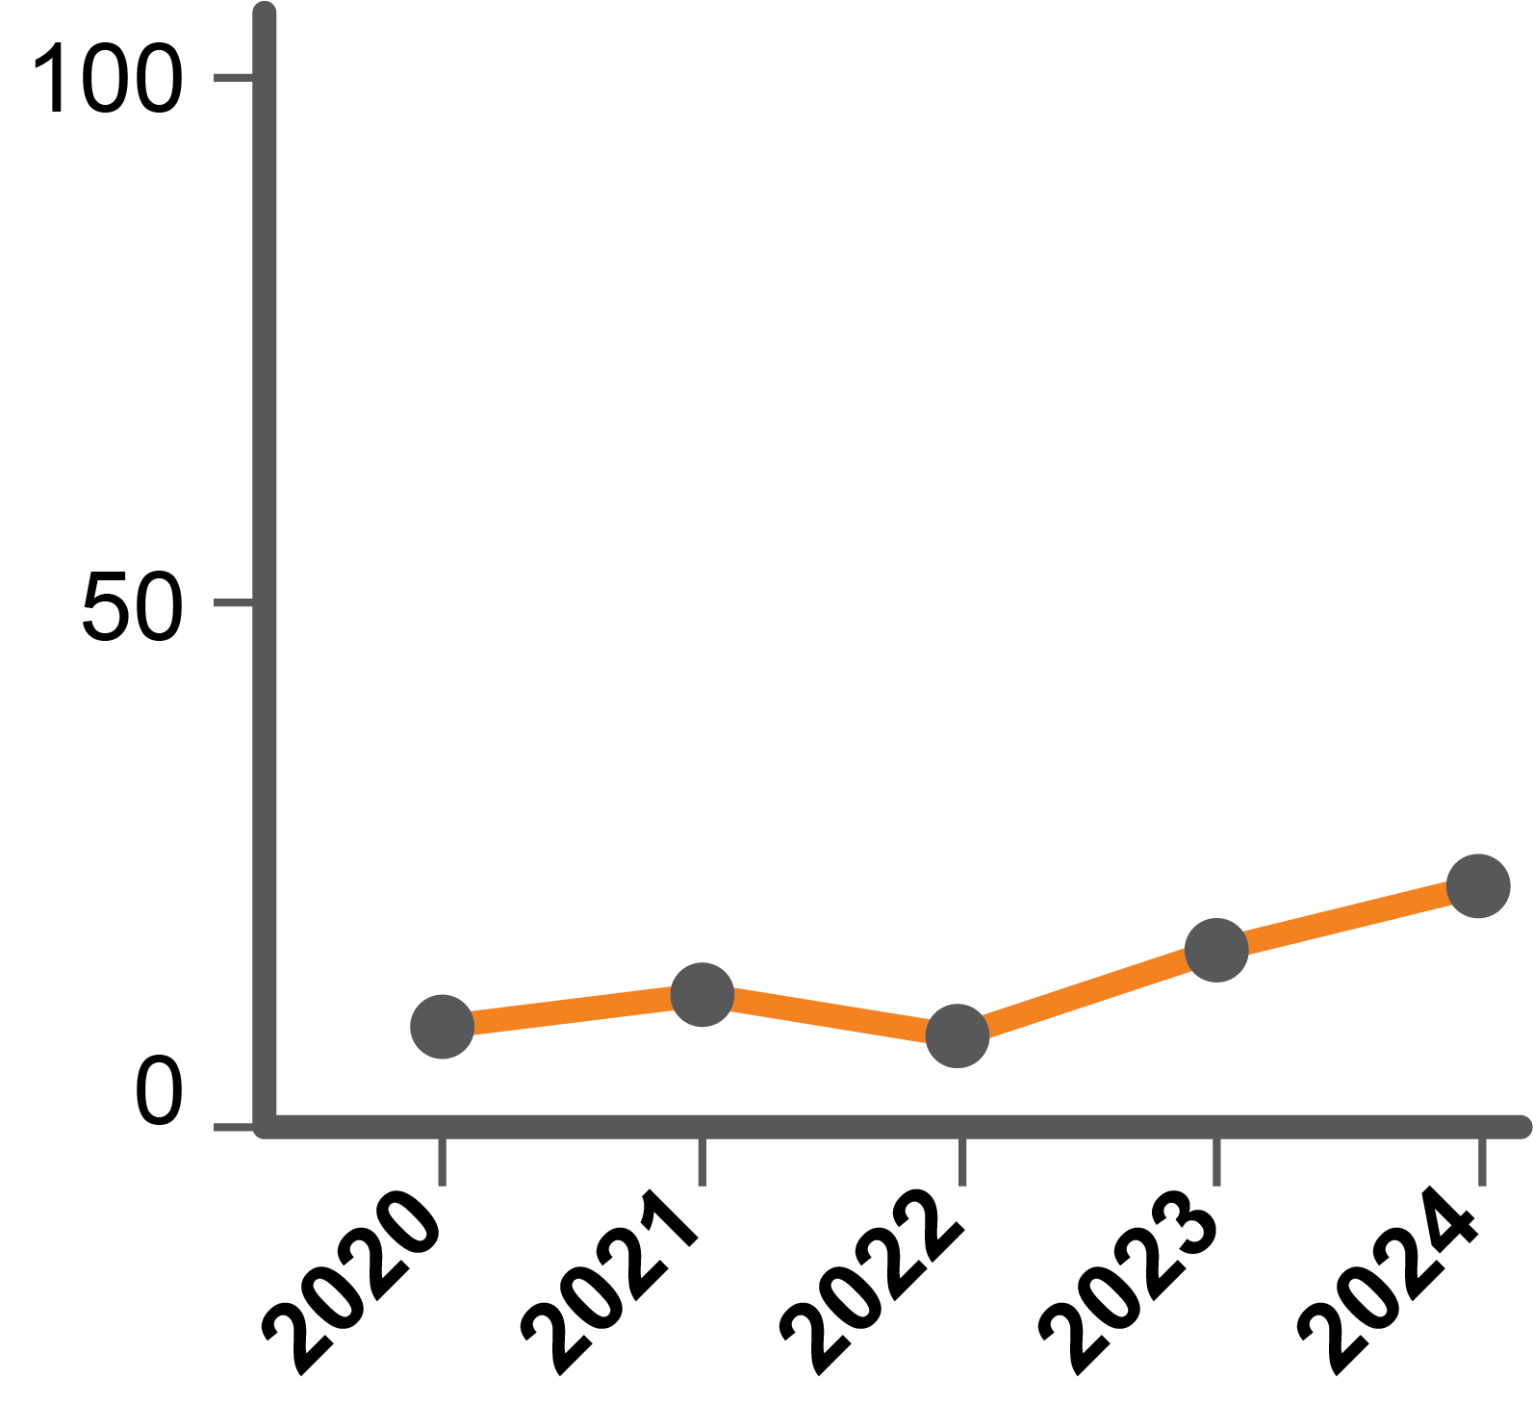
Chart A | Chart B
Task 3
Study the chart below.
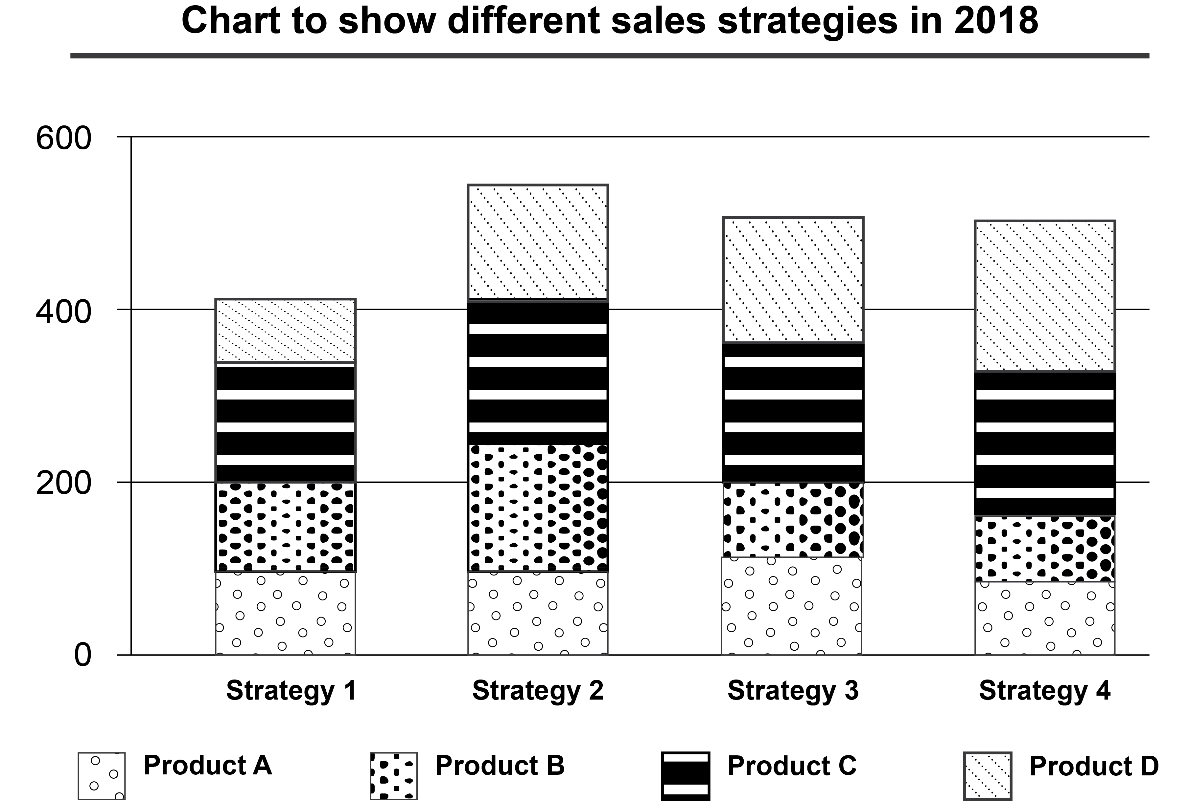

How has the design of the chart and the use of pattern helped show the data from the four different sales strategies detailed in the stacked bar chart above?
Use of bar chart

Use of pattern

Explain how you would use this data to improve sales for the next year. Use specific examples from the information above to support your answer

Data taken out of context can often be misleading. The chart shows a correlation between the sales strategies and the number of sales. What other factors could have affected sales?

