Name: Class:

Task 1
The picture below shows a range of signs deployed on different highways and byways. Look for trends or patterns in the way colour, shape and symbols are used.
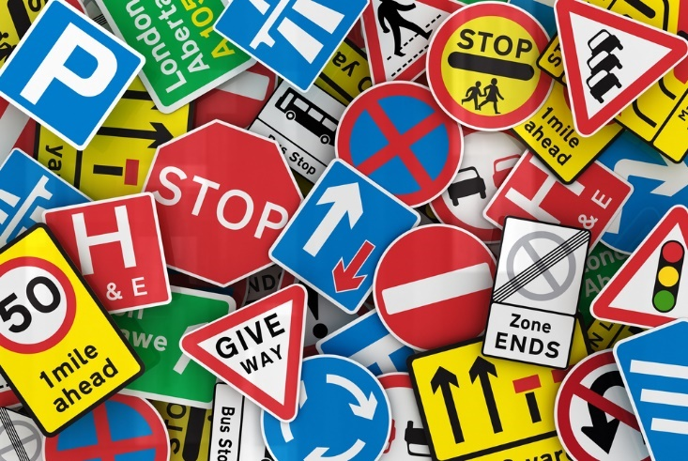
In the table below describe how each characteristic is used to communicate information.
 | Characteristic of sign
 | Colour | Shape | Symbols/Single letters
Meaning

Task 2
Study the line styles, symbols and the technical drawing for a candle holder below. Match the different styles of line and symbols to the correct meaning. An example has been done for you.
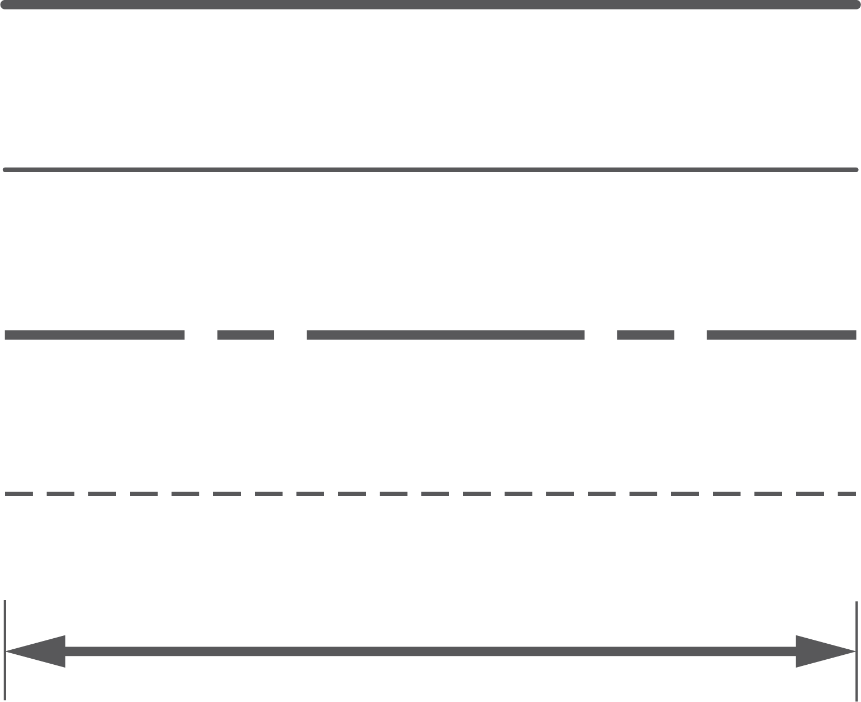 |  | Centre lines
 |  | Visible parts of an object
 |  | Projection lines/leader lines
 |  | Diameter
 |  | Radius
Ø |  | Dimensions
R |  | Hidden parts
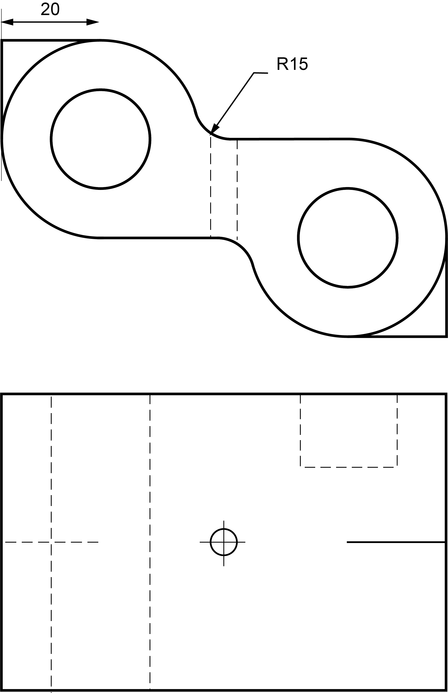

Label any other dimensions/markings that would be required to manufacture the part shown above using the correct conventions.
Task 3
Study the technical drawing below.
What is the name of two dimensional drawing method shown?

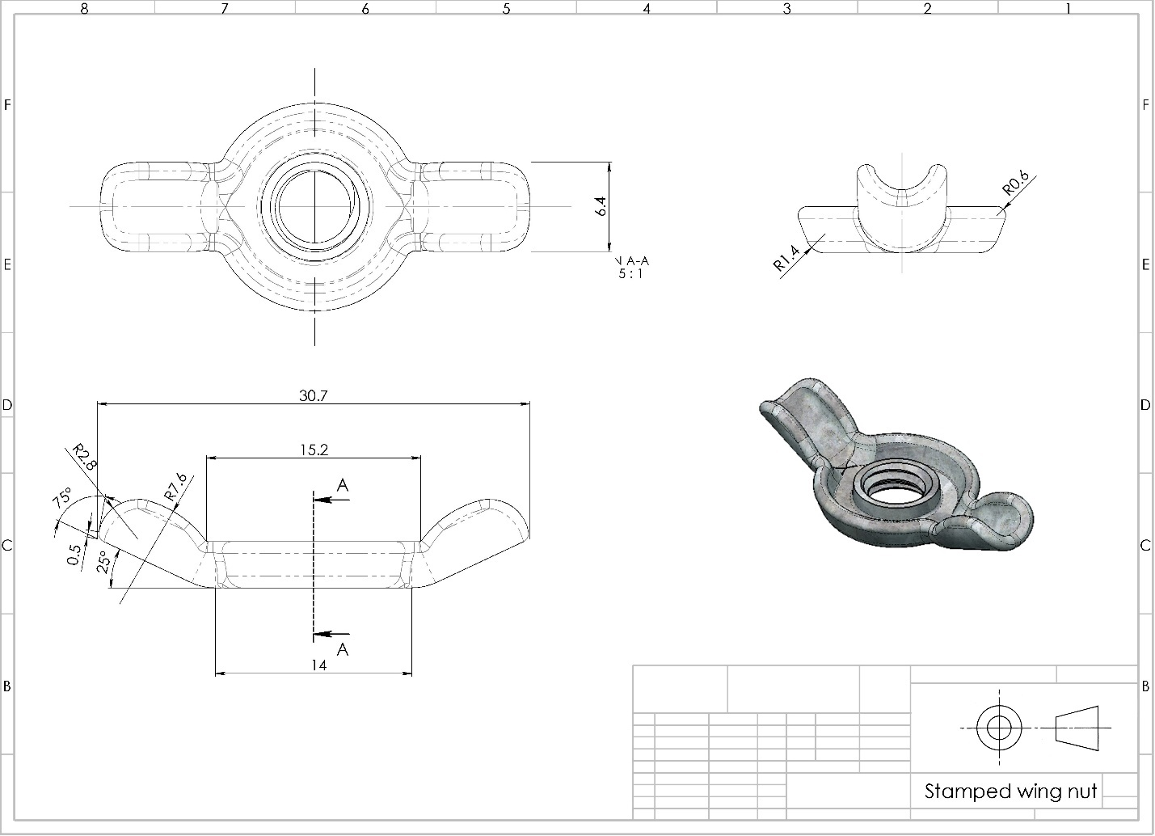
Draw a sectional view at point AA in the space below.
