Name: Class: Mark:

1. Which of the following best describes the drawing technique used to depict the
house below? [1]
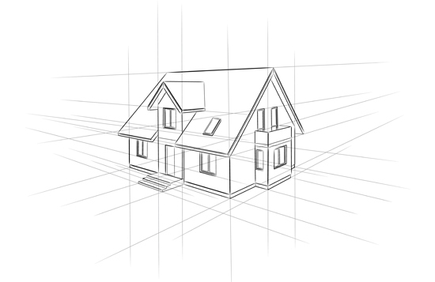
- Rendered drawing
- Two-point perspective
- Isometric projection
- Oblique projection

2. Name the three main 2D views generated using 3rd angle orthographic projection. [3]

3. This question is about colour coding and design communication. The image of the electrical resistor below show how coloured bands are used to show the value of a resistor in ohms.

(a) Explain one advantage of using colour coding in this instance. [2]

(b) Explain one disadvantage of using colour coding in this instance. [2]

4. Give one scenario when it would be preferable to use a 2D drawing technique to
present a final product to a client. [1]

5. Describe why designers use sectional drawings. [2]

6. Describe two advantages of freehand sketching over computer generated images. [4]

[Total 15 marks]

