Name: Class:

Starter Task
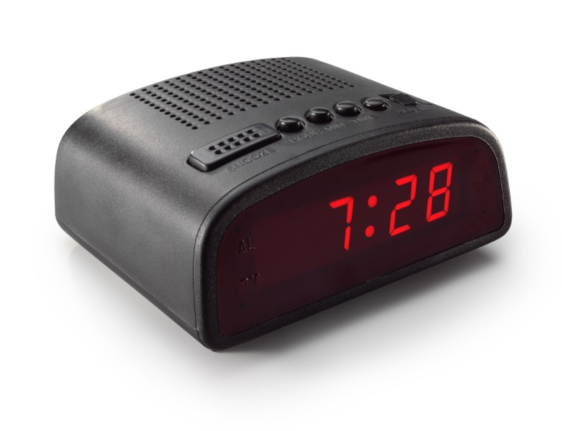
List five features that can improve this alarm clock to be an inclusive product.

1:
2:
3:
4:
5:

Explain two reasons why the points you have made are important to improve the alarm clock.

Task 1
In the table below, under the headings provided compare the different accessibility features of the two different transports methods, modern city bus and train focusing particularly on elderly users as well as adults with children and pushchairs and disabled users.
Modern City Bus | Train
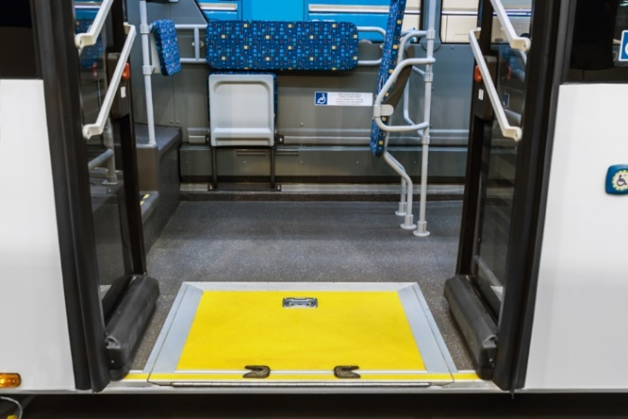 | 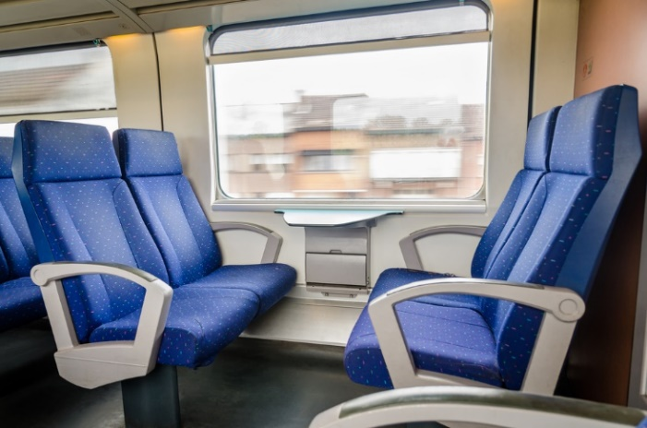
Access | Access
Seating | Seating
Communication / information | Communication / information
Highlight one way in which either transport systems have considered people with visual impairment.

Task 2
Study the image below and use the principals of inclusive design to redesign the kettle using annotated sketches which highlight key features / parts.
The kettle should function as expected but also meet the needs and ensure the safety of a diverse user group including the elderly, disabled and children.
