Name: Class:

Task 1
Name two pieces of legislations that have been formed to promote safe working practices.

What is the requirement of a workplace to ensure they comply with Health and Safety at Work Act (1974)?

What is the purpose of Control of Substances Hazardous to Health (COSHH)?

Task 2
The table below lists tasks that are common activities in a school workshop.
Fill in the hazardous substances and potential health harms linked with each of the tasks.
The first one has been completed for you.
Task | Hazardous substance | Potential health harm
Soldering in components | Fumes | Respiratory issues / asthma trigger /
Sawing / sanding wood

Gluing - epoxy resin

Finishing - spray paint

State the meaning of the following hazardous symbols:
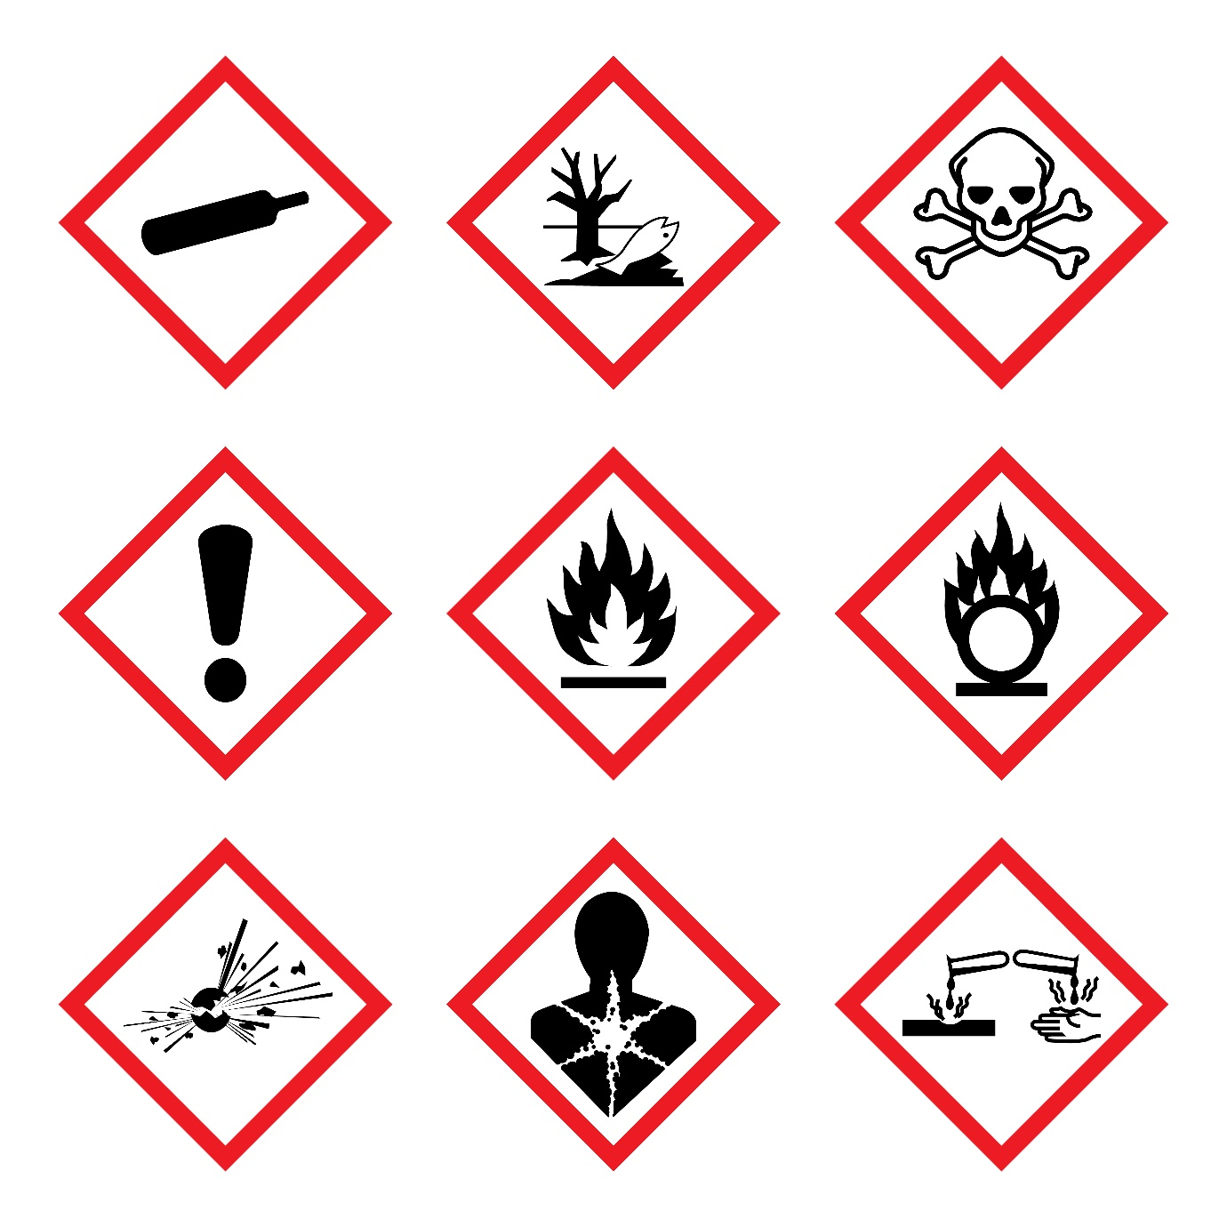

-----------------------------------
-----------------------------------
-----------------------------------

-----------------------------------
-----------------------------------
-----------------------------------

-----------------------------------
-----------------------------------
-----------------------------------

List four features a manufacturer must consider for the packaging of hazardous substances:
1:
2:
3:
4:

Task 3
Complete the following safety sign table:
Sign | Meaning / Purpose | Instruction / Information
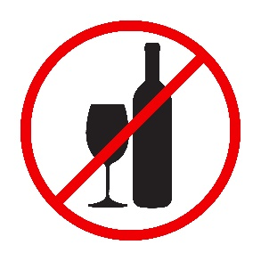
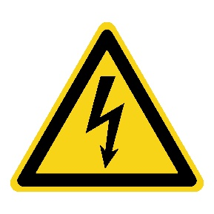
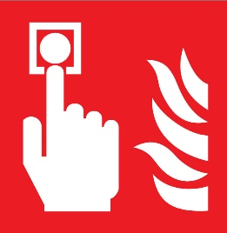

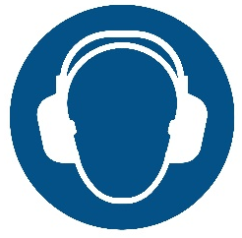

Task 4
Study the hanging soft toy mobile pictured below.

Suggest three aspects of the toy that would need to be tested to ensure safety and enable the toy to display the Lion Mark.

