Name: Class: Mark:

1. State what the abbreviation ‘COSHH’ stands for. [1]

2. Explain what the following symbol means. [1]

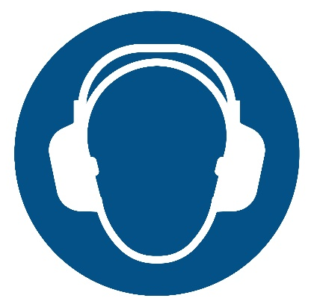

3. Match three of the five safety precautions with the correct symbol. [3]

Fire safety |  | 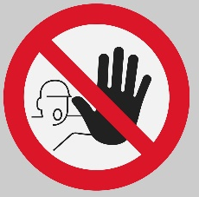
Mandatory
Prohibition |  | 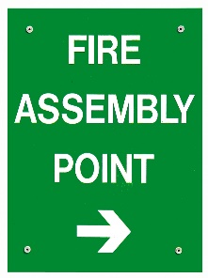
Safe Condition
Warning |  | 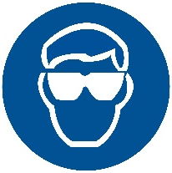

4. Epoxy resin is a popular two-part adhesive consisting of Part A, a resin and Part B, a hardener.
The two parts come in separate tubes or in containers that feature two chambers within one unit, such as the one pictured below. When used, the contents of both chambers are extruded and are ready to be mixed. The adhesive hardens as a result of a chemical reaction between part A and B. This adhesive is used to join a wide range of materials.

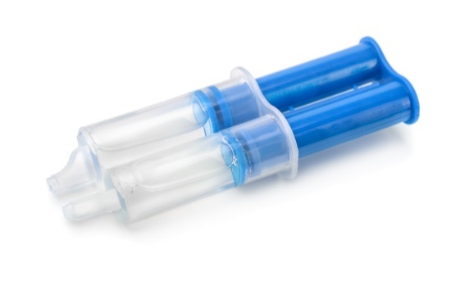
(a) Explain two pieces of information you should expect to see on the packaging of this type of adhesive. [4]

(b) The following hazard pictogram should be included. What does it mean? [1]
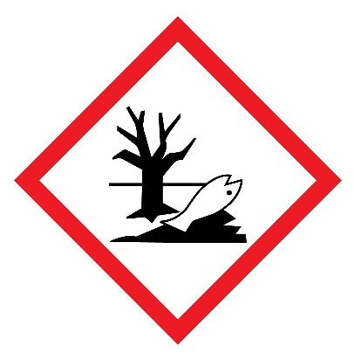

5. As part of managing health and safety in a workplace, risks must be judged by anticipating what might cause harm deciding whether you are taking reasonable steps
to prevent that harm. This is known as risk assessment.
Complete the following risk assessment tables for:
(a) Operating a belt sanding machine [4]
(b) Exposure to wood dust in a workshop [4]

What are the hazards? | Who  might be harmed? | How might harm be caused? | What measures are in place? | What further action is necessary? | Action by whom?
Operating belt sanding machine
Exposure to wood dust

[Total 18 marks]

