Name: Class:

Task 1
1. What is meant by the term ‘Intellectual Property’?

2. Explain the rights of intellectual property.

3. Complete the table by ticking two applicable forms of design protection for each product pictured.
 |  | 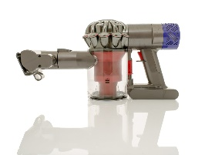 | 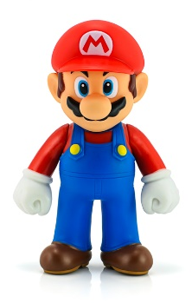 | 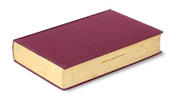 | 
Copyright
Design Right
Intellectual Property
Patent
Task 2
1. Complete the following table:
 | What does it protect? | Automatic or application required? | How does it protect? | How long does it protect for?
Copyright
Design right
Patents
Task 3
1. Complete the following table:
 | What does it protect? | Automatic or application required? | How does it protect? | How long does it protect for?
Registered designs
Trademarks and logos

2. Explain what is meant by the term ‘open design’ and how it helps society.

