Name: Class:

Task 1
For each of the products pictured below specific materials have been used so that they are fit for purpose – complete the table below explaining the purpose of each product and reasons of why each material is fit for purpose.
Item | Materials | Specific purpose | Reasons
 | Waxed cotton  wrap
 | Polypropylene  container
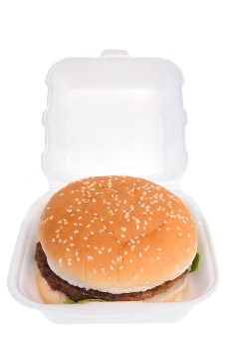 | Polystyrene  take-away box
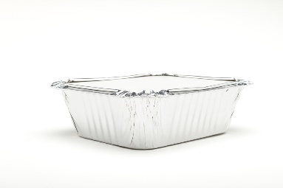 | Foil container
 | Pizza box
Task 2
Study the exploded view of the handheld vacuum cleaner below.
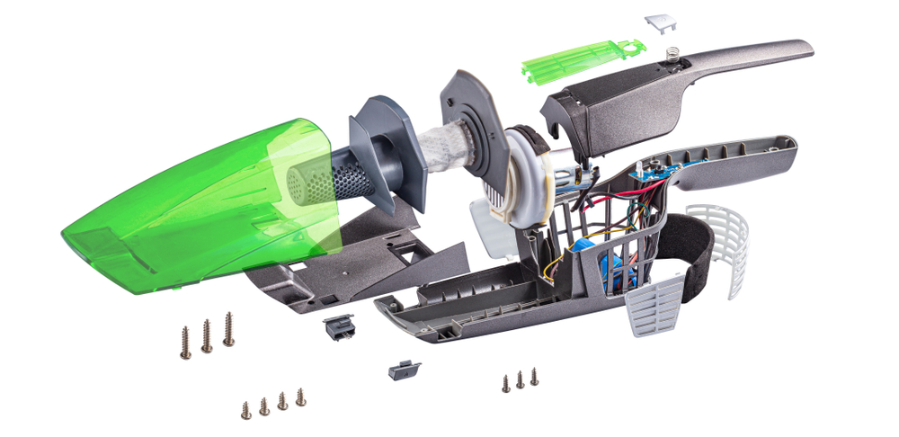
Explain why it is important to be able to disassemble a product with ease.

Task 3
Study the two products below.
For each one, suggest and explain how the two of the 6 Rs listed could be applied to increase its sustainability.
Cardboard packaging
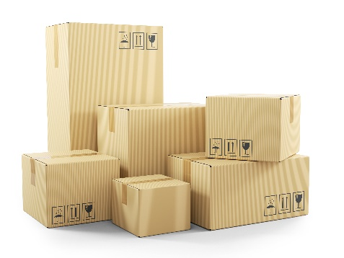
Reduce:

Recycle:

Trailer and tarpaulin cover
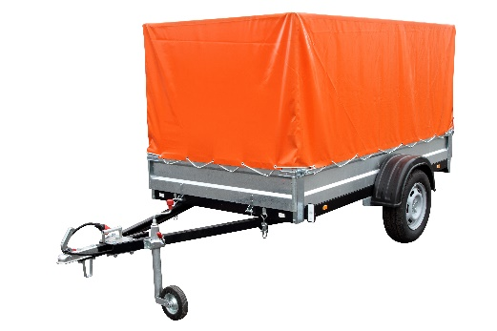
Repair:

Reuse:

Task 4
List three advantages of carrying out regular maintenance on the washing machine pictured below.
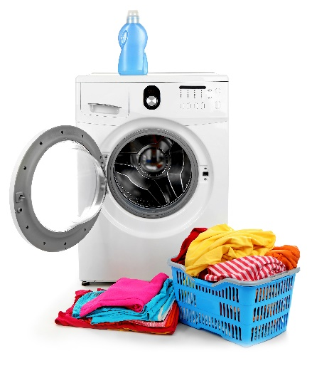

Task 5
Some products are designed to be repaired by trained specialists only, whereas some are designed to be repaired by the end user. Identify different products, equipment or machines and list them under the applicable heading in the table below.
Trained Specialist | End User

