Name: Class: Mark:

1. Suggest and explain two considerations that a designer must take into account when choosing appropriate materials for a product. [4]

2. Legislation and guidance have been introduced in order to limit the effects of consumer products upon the environment.
Discuss the impact these measures have had on products, packaging and end of life disposal. [6]

3. This question is about the disposal of products and the Six Rs of sustainability.
(a) Which three of the Six Rs of sustainability relate specifically to waste management? [1]

(b) Explain why each of these are important in waste management. [3]

4. List two advantages of using standardised parts in production and assembly
of products. [2]

5. Study the images below.

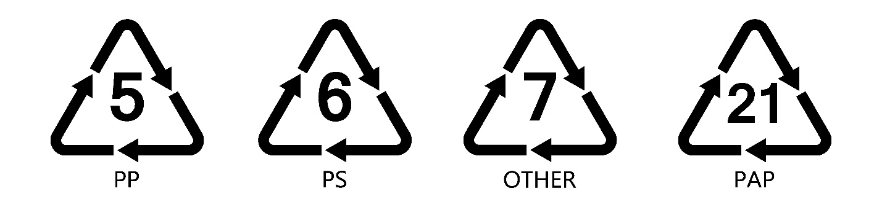

Explain what recycling codes are and how they are used. [4]

[Total 20 marks]

