Name: Class:

Task 1
When considering ease and efficiency of manufacture, what factors should a manufacturer take into account?

Task 2
Tick the correct type of snap fittings used in the following products
 | 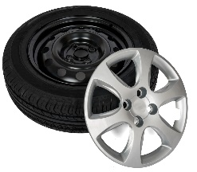  Plastic Hub Cap | 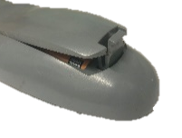  Remote Control |   Lunch box lid | 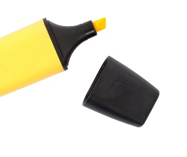  Highlighter lid
Cantilever
Annular
Torsion
U-shaped

Suggest two disadvantages for using internal moulded screw posts.

Task 3
Study the image of the car stereo below
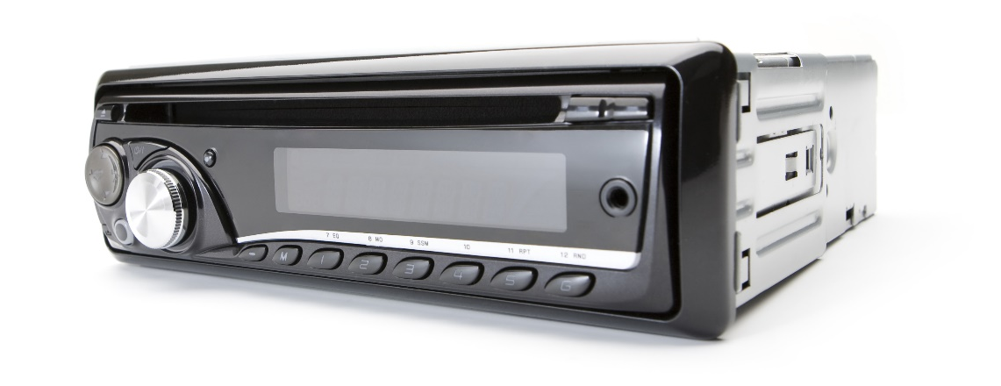
Explain why an automotive manufacturer would choose to order in pre-made components such as this car stereo.

