Name: Class: Mark:

1. Suggest two ways in which efficient manufacturing techniques can make a positive environmental impact. [2]

2. Give three reasons for roll forming ribs or corrugations into sheet steel used for roofing. [3]

3. Which one of the following does not contribute to efficient manufacture? [1]
- Designing to reduce material thickness
- Using pre-made components
- Working to standardised sizes
- Using bespoke fittings and fixtures
4. Name two types of snap fittings and give examples of where they can be used. [4]

5. Give two reasons why snap fittings are often used in injection moulded
polymer products. [2]

6. Study the polymer power tool carry case below.

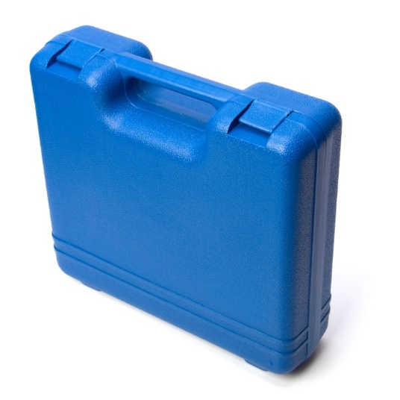
Discuss the ways in which this carry case has been manufactured with efficiency
in mind. [6]

7. Give two advantages and two disadvantages of using of using pre-made components
in manufacturing products. [4]
Advantages:

Disadvantages:

[Total 22 marks]

