Name: Class:

Task 1
What is meant by the term ‘design for disassembly’?

Explain two important factors a designer should consider when designing a product for disassembly.

Task 2
Explain how the soap dispenser bottle below has been designed with disassembly in mind and how it can be modified to improve the design for disassembly.
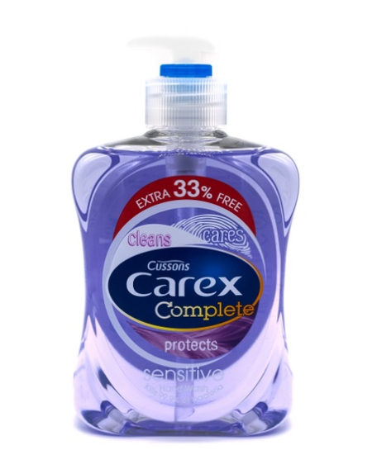

Task 3
Shape memory alloy (SMA) is used as part of active disassembly.
List three advantages ADSM has to offer the disassembly process.

Task 4
The outer casing of the eco-pen pictured below is made from recycled biodegradable paper
and biopolymer.

How can using biodegradable parts help with disassembly of products?

