Name: Class: Mark:

1. Suggest and explain two advantages to the environment of designing a product for disassembly. [4]

2. With reference to design for disassembly, state three potential impacts of an
inadequately designed product. [3]

3. List four things manufacturers should actively avoid when seeking to produce
sustainable products that are serviceable easy to disassemble and recycle. [4]

4. Study the chair below.

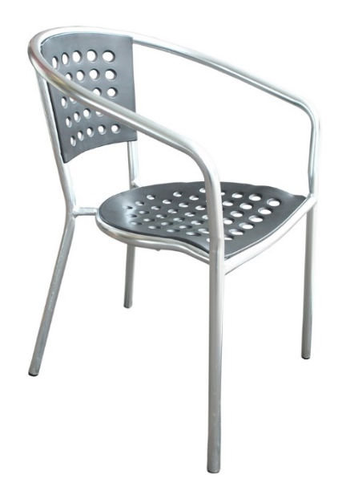
The frame is made from welded stainless-steel tube, the seat and back are riveted to
the frame and made from moulded Polypropylene and the feet are made from ABS.
Discuss the existing chair design in terms of disassembly and suggest modifications
where these would make disassembly for maintenance and end-of-life
recycling easier. [9]

[Total 20 marks]

