Name: Form: Marks: / 14

Task 1
Look carefully at the products in the table below. Think about which is the most appropriate method of production and fill in the table.
 | 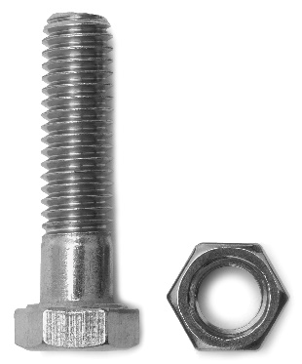 | 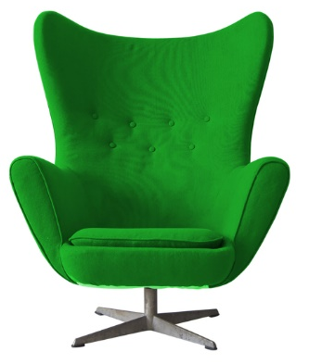 | 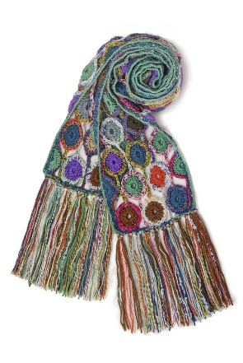
Suggest one suitable scale of production
Give three reasons
(per product) for your choice

Task 2
Read the company profile below.
Plast-eco Mouldings Inc
Plast-eco Mouldings Inc is an established manufacturing outfit producing injection moulded plastic storage solutions (boxes, bins, pallets etc.). They manufacture in a large warehouse in East London, half of which is plant (two injection moulding units) and the rest of which is divided between materials storage and stock. They buy their raw materials in pellet form from a supplier whose prices are very competitive but whose stock is inconsistent.
All waste plastic from the injection moulding process, sprues, runners and any overflow that leaks out is collected in hoppers and sent to a recycling plant in West London to be chipped and processed for reuse.
Plast-eco Mouldings Inc have customers all over the country. Plast-eco Mouldings Inc regularly fulfils repeat orders, however occasionally when customers change their orders or fail to re-order, they are left with unsold stock. Recently Plast-eco Mouldings Inc has taken on a new managing director, her aim is to make the business more financially viable.
In the space below, suggest and justify four strategies which you feel Plast-eco Mouldings Inc could use to streamline their business making production 'leaner' and more flexible, thus achieving the aim of making the business more financially viable.
Suggestion 1

Suggestion 2

Suggestion 3

Suggestion 4

Task 3
Study the picture of the chair.
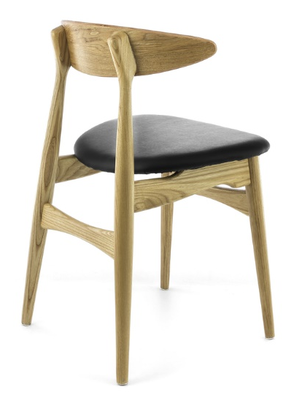
Aisha makes one-off pieces of furniture for clients from her workshop.
She has recently been commissioned to design and make a batch of 60 dining chairs like the one pictured for a local restaurant.
Suggest and explain two manufacturing methods Aisha could use to ensure consistency and to control the quality of the chairs.
Manufacturing method 1

Manufacturing method 2

