Worksheet 2: Efficient use of materials and resources
Task 1
Add as many manufacturing processes as you can to the appropriate section of the Venn diagram. An example has been done for you.
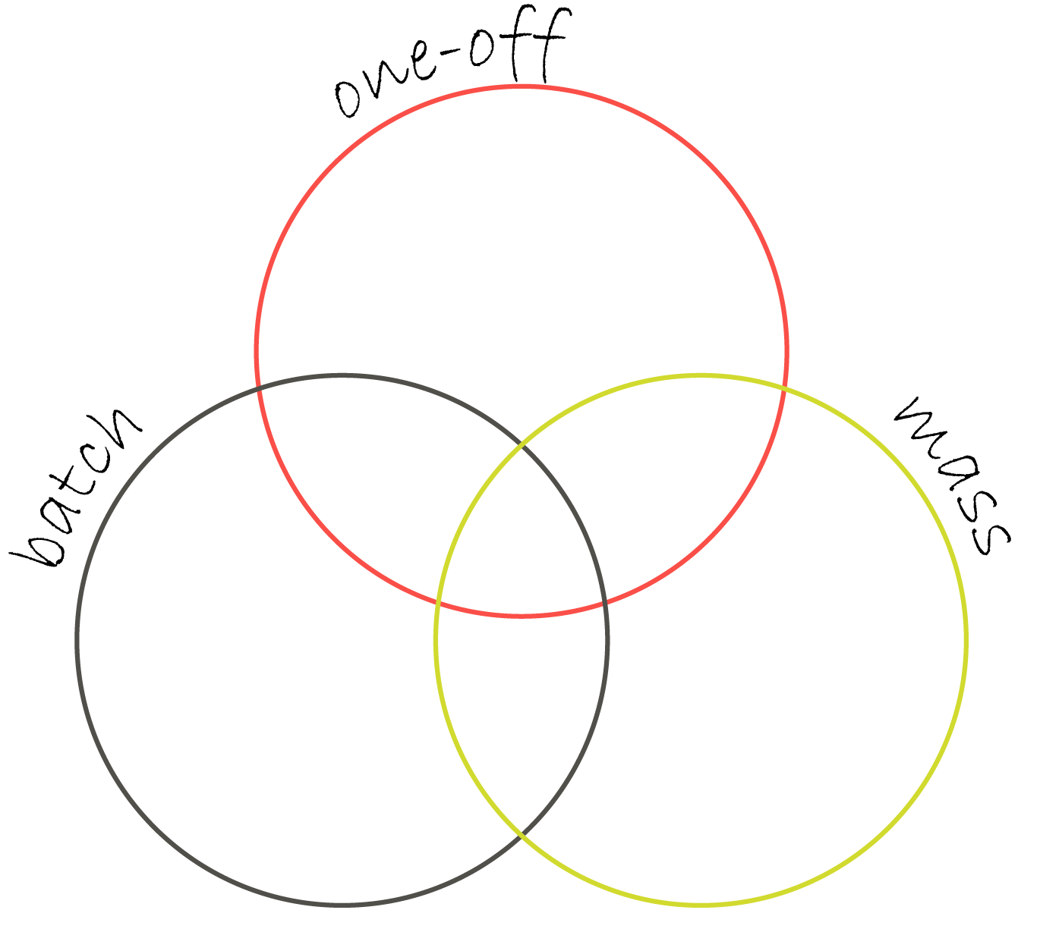
e.g. Laser-cutting

Task 2
The handle below is designed for a small cabinet. It is to be 3D printed in polylactic acid (PLA) as part of a one-off prototype.
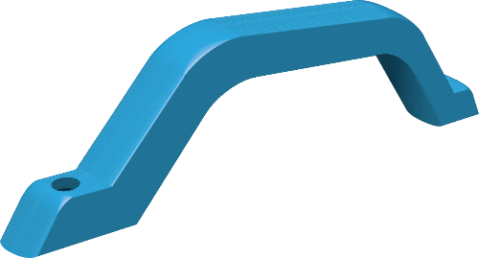
The cabinet is to be developed for a mass-production. The shape and form of the handle may be modified as long as the basic function of the component is fulfilled.
Propose two suitable processes for mass-producing the handle and the material you would use in each case.

Explain why the processes you have selected are suitable for mass-production.

Based on the success of the mass-produced product, the manufacturers decide to produce an exclusive, limited-edition model.
What scale of production would be suitable for this product? Explain your answer.

Task 3
The chess piece below is called a pawn. A manufacturer plans to make a batch of 15 chess boards and each board needs 16 pawns. The pawns are to be turned from a wooden 25mm dowel measuring 1000mm in length.
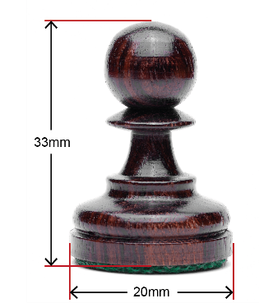
How many dowels will be needed to make the total number of pawns required? An allowance of 2mm needs to be added to the height of each pawn for waste when parting off.

How could the design of the pawn be developed to make more economic use of the dowel?

Another manufacturer is mass-producing chess pieces using injection moulding. How could the shape of the pawn be modified to make best use of materials?

The two products below are designed to protect products during transit. Study their credentials.
Product A | Product B
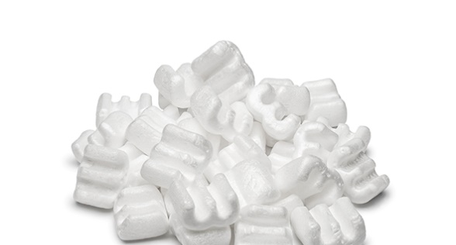 | 
Packaging peanuts made from expanded polystyrene (EP) | Air-filled packaging cushions made from low density polystyrene (LDPE)
Which of these products makes more economic use of materials? Explain your answer.

Task 4
Compare the processes below in terms of waste reduction and accuracy.
Moulding fibreglass | Injection moulding
The Panton Chair was once made from fibreglass but is now manufactured using
injection moulding. What are the disadvantages of injection moulding on this scale?

