Worksheet 3: Computer systems in manufacturing
Task 1
The diagram below shows the journey of a product throughout the stages of planning, storage and distribution. Fill in the boxes to suggest how computer systems may be used to plan and control production as well as reduce waste at each stage.
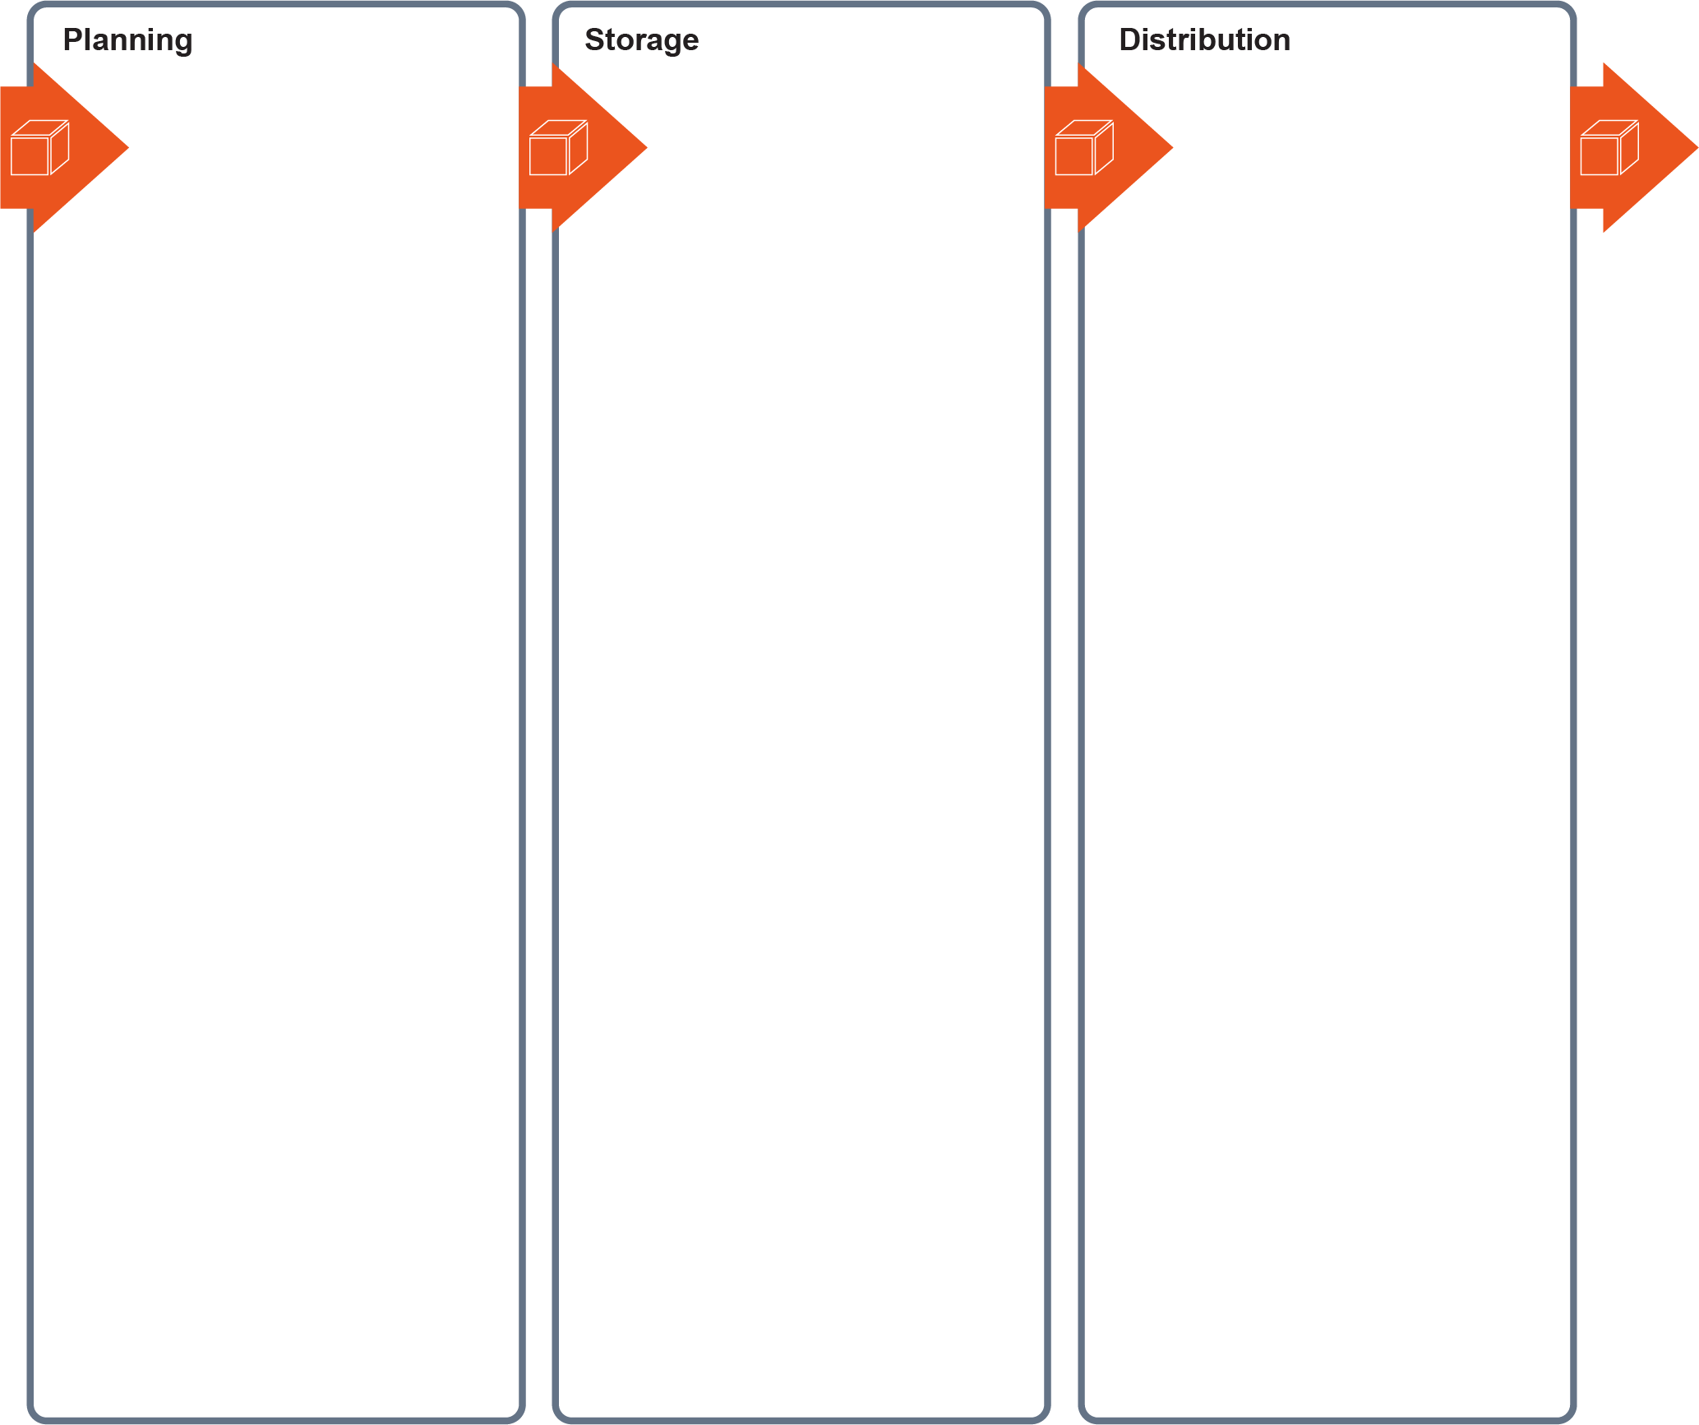

Task 2
Study the product and company profile and answer the questions below.

ProtectHead Ltd is a company making injection moulded bicycle helmets. They want to expand their range of products in response to market pull. Sales indicators demonstrate an increased demand for helmets for winter sports. ProtectHead Ltd currently have one CNC injection moulding machine and manufacture one style of helmet. The machine is managed by two members of staff; one operative sets up the machines and another removes the moulded parts from the dies after cooling. Raw materials are stored in a rented warehouse. Internal padding and straps are put together in a separate part of the factory.
Suggest and explain three changes the company could make to their existing set-up to increase efficiency and reduce waste. Refer to the following:
- Production
- Distribution
- Storage

Task 3
Label the products below to suggest at least two parts that could be bought-in or sub-assembled by another manufacturer. Be sure to take account of the specialism of the main manufacture.
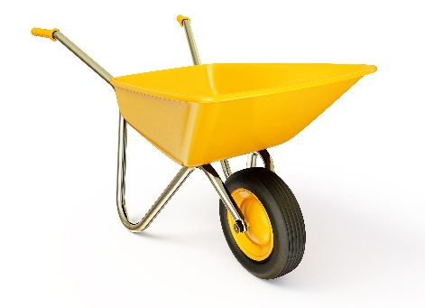 | 
Wheelbarrow  Manufacturer specialises  in metal fabrication | Flat-pack garden chair  Manufacturer specialises  in timber and carpentry
 | 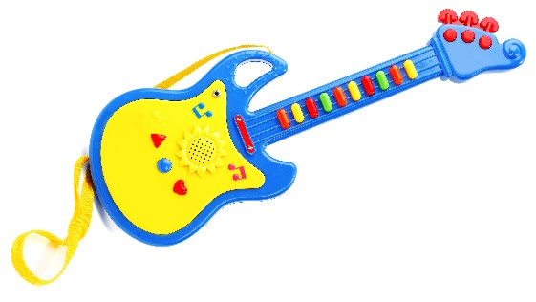
Desk lamp  Manufacturer specialises  in powder coated steel parts | Toy guitar  Manufacturer specialises  in injection moulding

Describe the advantages of using bought-in and sub-assembled parts

Task 4
Traditional manufacturing systems have developed to integrate computers which streamline production. Study the criteria below and mark a cross in the correct column.
 | Traditional Manufacturing | Computer integrated manufacture
Production driven by customer demand
Materials are stocked prior to production
Production driven by a sales forecast
QC and QA integrated into
the whole process
Waste generated is minimal
QC and QA performed by workforce
Materials are ordered just in time
Data analysis informs preventative actions
Waste is generated during production
Problems are corrected as they arise
Production schedules tracked in real-time

