Worksheet 4: Digital design
Task 1
Study the two models below. Focusing on architecture, explain how CAD modelling compares to physical modelling when developing a design proposal.
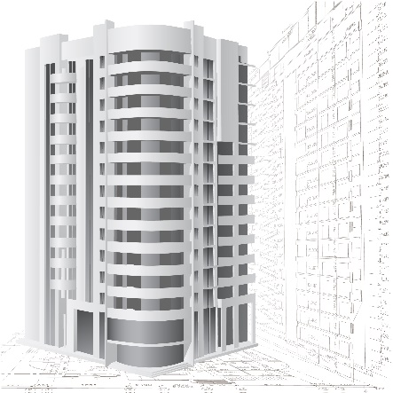 | 
CAD | Modelling by hand
One of the main advantages of developing prototypes digitally is that files can be exported to CAM machines. List the options for the computer aided manufacture of prototypes below.

Task 2
List an appropriate CNC process for the manufacture of the following products in the boxes provided below.
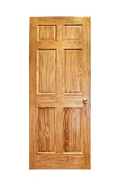 |  | 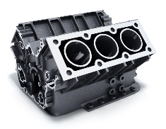 | 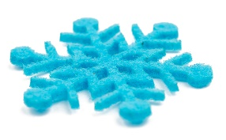 | 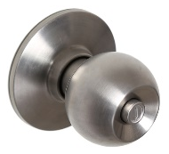
Oak door | Vinyl sign | Aluminium alloy engine part | Felt decoration | Stainless steel door knob

Task 3
A company wishes to produce engraved acrylic key fobs for hotels. Compare the pros and cons of using laser cutting vs CNC routing.
Pros and cons of laser cutting | Pros and cons of CNC routing

