Worksheet 5: Modelling, testing, marketing and scheduling
Task 1
A small UK civil aviation company specialising in the design and manufacture of light aircraft are developing a small passenger plane designed for regional, short flights. The plane will fly at lower altitudes and thus be subject to turbulence.

(a) Explain two virtual simulations that the manufacturer could run to gain insight into the aerodynamics and performance of the aircraft fuselage and engine. Discuss how this could inform the development of the design of the aircraft.

(b) What other design features and systems of the aircraft could be tested in this way?

(c) Describe how virtual simulations benefit the aircraft manufacturer.

Task 2
Study the prototype below which has been produced using rapid prototyping techniques.
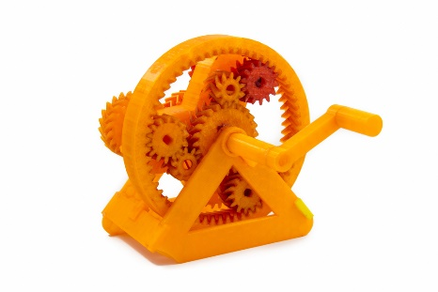
List as many advantages of rapid prototyping as possible under the headings below.
Versatility and innovation | Time | Cost

Sharing ideas | Risk | Customisation
Task 3
A start-up company making and selling 3D printed jewellery have a small shopfront and, due to demand, want to expand to sell their products online. How might an EPOS system benefit them?

Task 4
Consider the role of production, planning and control (PPC) networking. Match the data streams below to the correct aspects of the manufacturing process.
Aspects of manufacturing |  | Data streams
Procuring materials |  | Order details and GPS product tracking data
Scheduling of machines |  | Data from parts/products scanned on production line
Coordinating suppliers  and customers |  | Data from AVGs

