Name: Class: Mark:

1. Name one type of market research a designer might carry out before developing
solutions for a new product. [1]

2. Explain the difference between primary and secondary research. [2]

3. Market research is vital to product development.
(a) State two reasons why designers carry out market research and engage
focus groups. [2]

(b) When designing a mobile phone, ergonomics and anthropometric data will be considered throughout the development of the product.
(i) Explain two specific anthropometric data sets that would be useful when
designing a mobile phone. [4]

4. Explain why it’s important to consider a wide range of possible user groups when
designing a product. [2]

5. Choose one of the images below and sketch and annotate three improvements to the
design which would enable a user with restricted hand grip to easily use the product. [3]

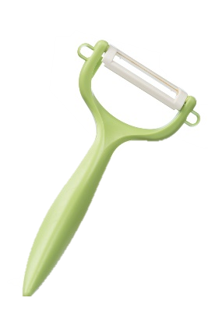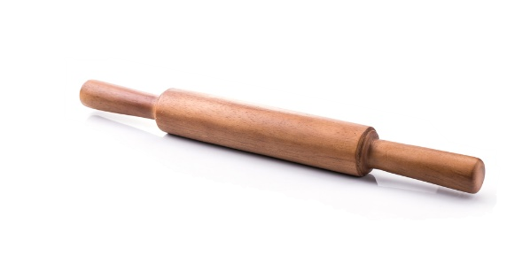

6. Study the image of the office chair:
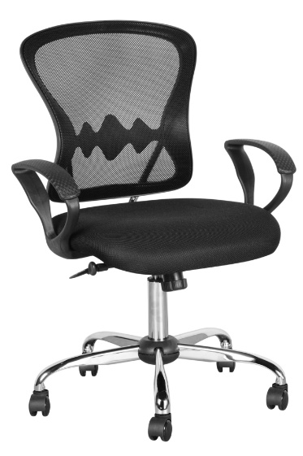
Explain how market research and the analysis of anthropometric data would
have been gathered and used to dictate the form and function of the office chair. [8 marks]

[Total 22 marks]

