Name: Class:

Task 1
Using the images of the Solomon R Guggenheim Museum below, discuss Modernism’s theory of ‘form follows function’ in relation to the museum.
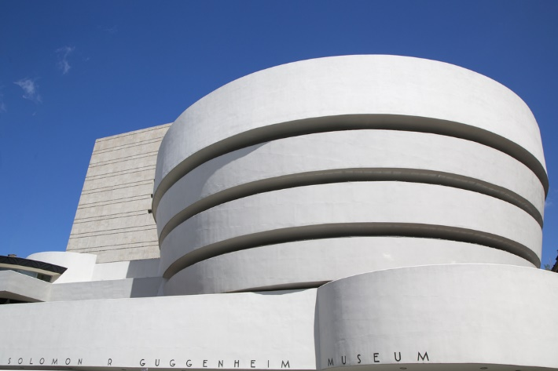 | 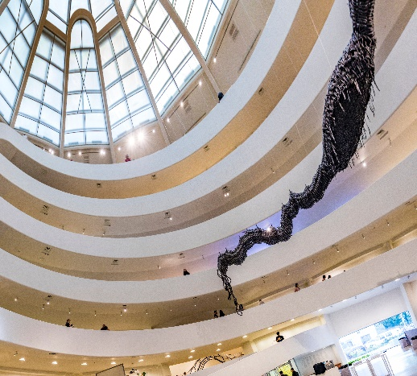 | 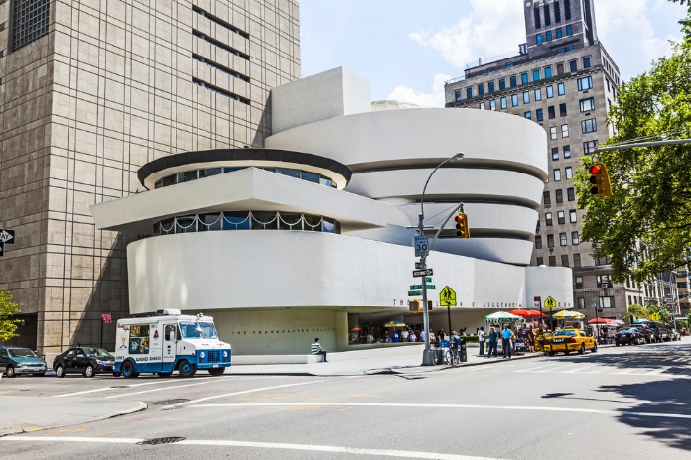

Task 2
From which design movements do the following images exhibit characteristics?
Justify your response.
 |  | 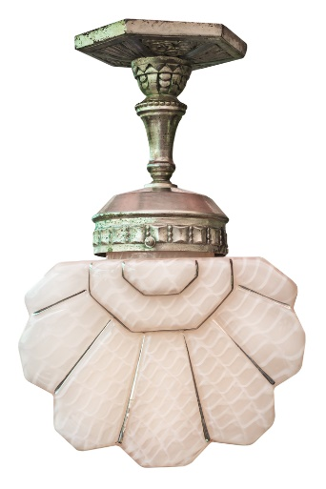
Image 1 | Image 2 | Image 3

Image 1:

Image 2:

Image 3:

