Name: Class:

Task 1
During the war efforts, it was expected that the public would give up products, so the materials could be used in manufacture of war related products.
In pairs, discuss the types of household products that you think you could be asked to donate
if our country was at war and in short supply of materials such as metals.
List a few examples.

Task 2
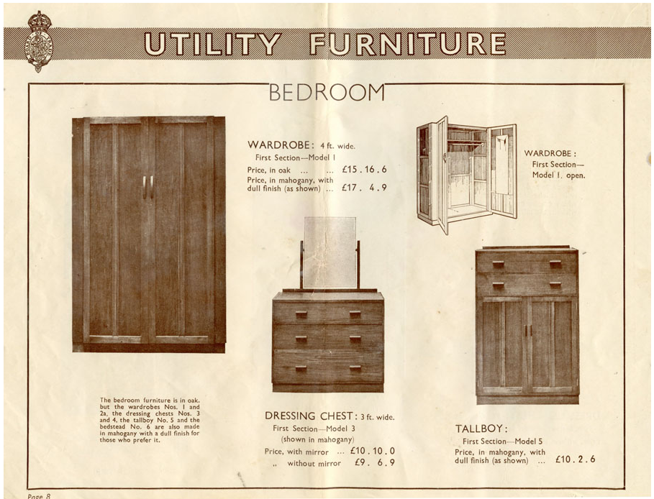
Study the image above. In pairs, discuss what features are indicative of ‘Utility furniture’?
Write down your findings.

