Name: Class:

Task 1
Most often, types of products have a defined product life cycle. This is often linked to the technology and user needs of the time.
Study the images below and suggest what stage of the product life the type of technology pictured is currently in and justify your answer.

Product | Stage in  life cycle | Justification
Compact digital camera
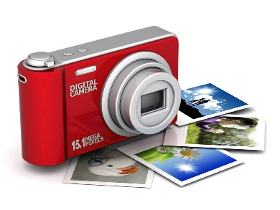
All electric vehicle
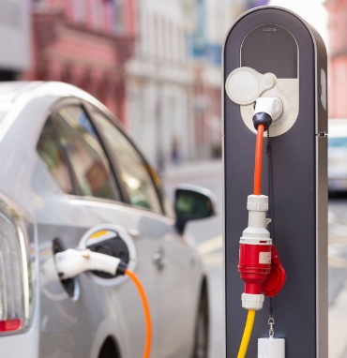
Tablet

Robotic assistants
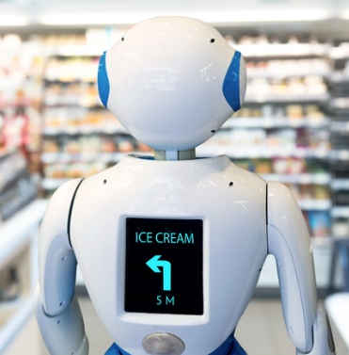
Task 2
Select one product that you are familiar with that has been established for many years. Discuss the different stages of the product’s life cycle and the evolution of your selected product over time. Highlight the differences of new models or versions, suggesting why they were implemented and what the effect may have been. If appropriate to the product go on to discuss its decline and replacement.

