Name: Class:

Starter Task
Annotate the cyclic design process below. Give detail on what each stage of the process might entail. Examples have been given below.
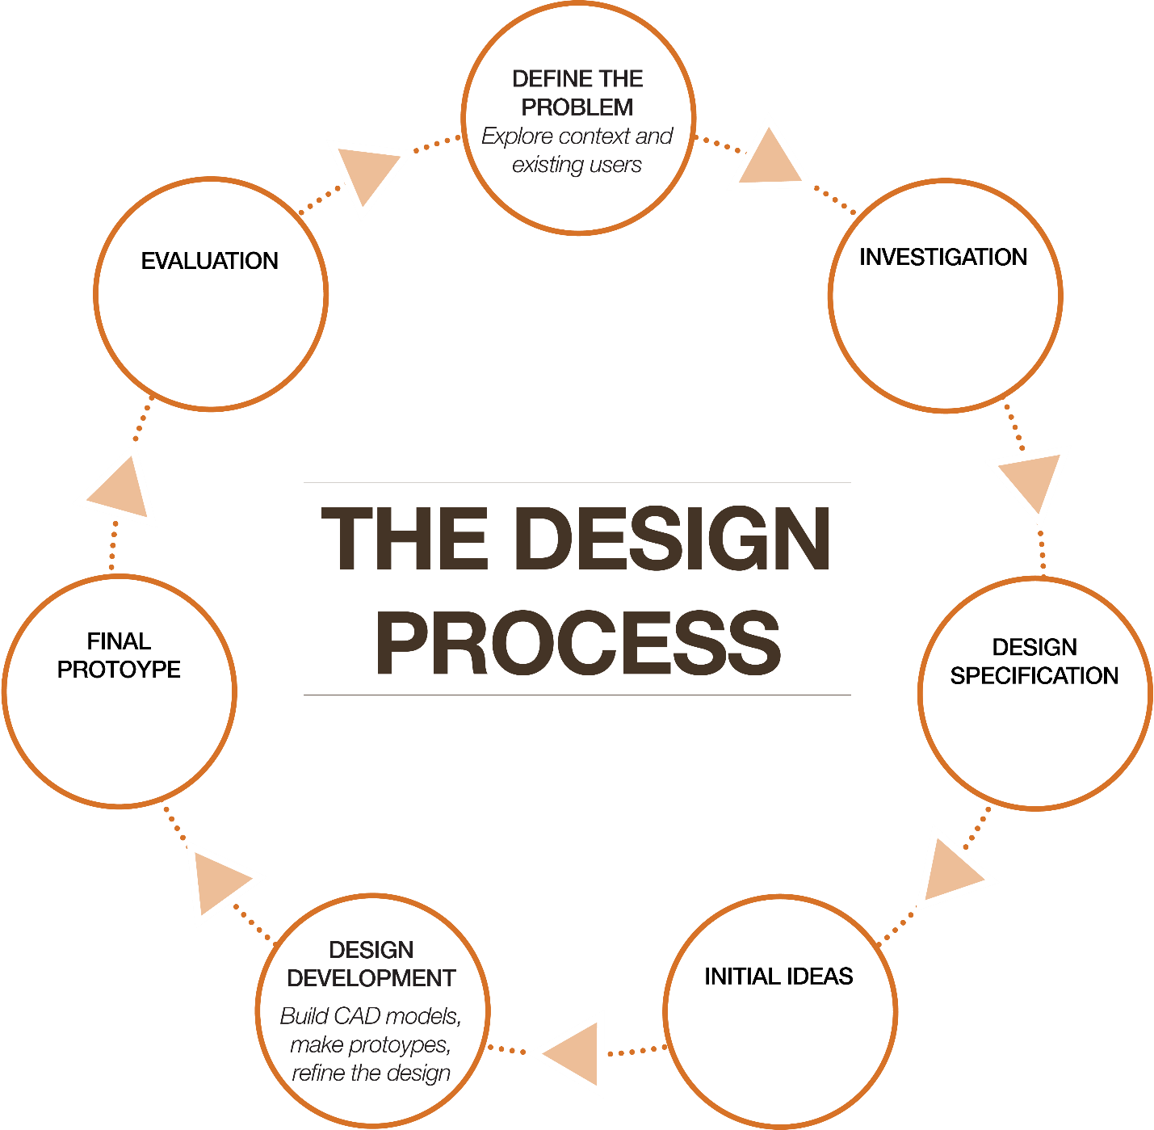

Task 1
Choose one of the images below and list a range of potential problem areas. Include potential clients, why the problem is important to solve, what needs to be found out and include some research methods you could use to do this. An example has been given below.
Option 1 |  | Option 2
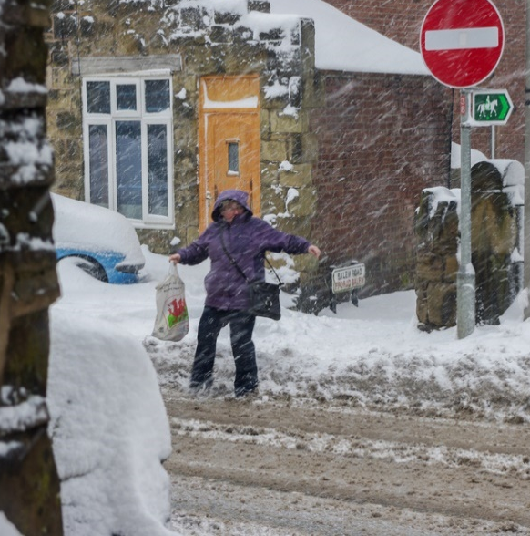 |  | 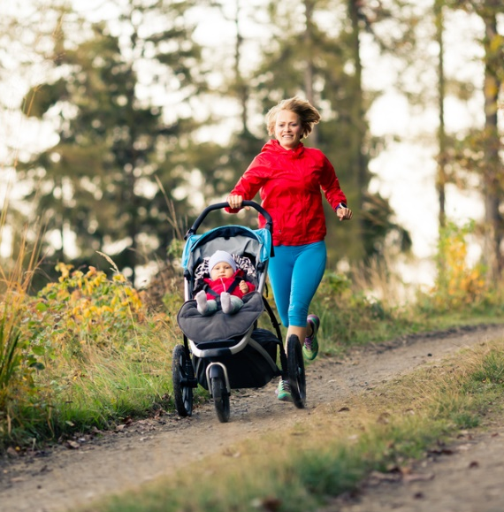

Potential Problem Areas | Potential Client | Importance  of solving problem | What needs to  be found out | Research methods to use
Adverse outdoor weather conditions for….

Anthropometric data for grip size, height of users.
Product disassembly.
Media diary of potential clients.
Focus group interview with active parents.
Task 2
A major sporting equipment company are developing a drinks container to be used by active individuals who wish to take drinks with them to sporting events.
Based on consumer research, there is currently a lack of lightweight insulated sports drinks containers on the market. This would be of use to keep drinks chilled for a length of time or keep hot drinks ready for after sports. Additionally, those interviewed suggested that one current issue with drinks containers was that the diameters of drinks containers were usually over 45mm and therefore too large to keep in car cup holders.
A preferred amount of liquid to have was 1 litre and most noted there were not many drinks containers with this capacity.
List four specification points based on the information given above for the design of a portable drink container. Justify each or your specification points.

Task 3
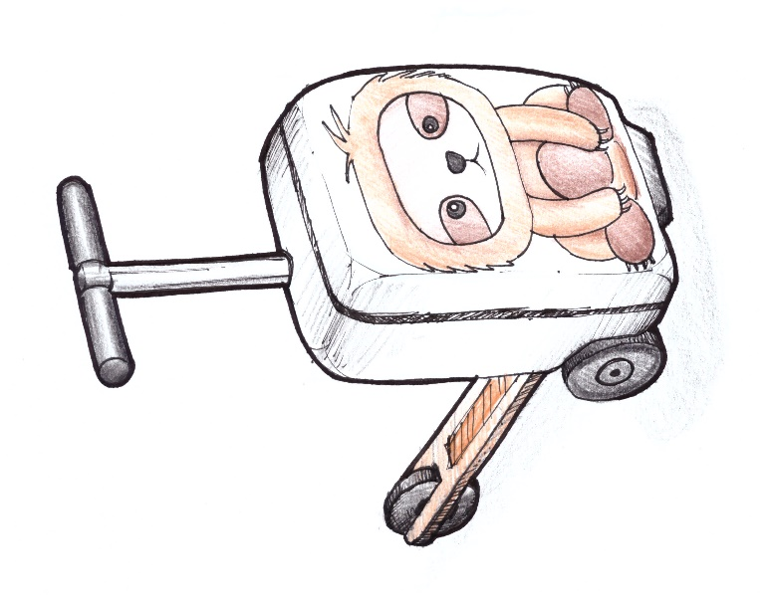
A company specialising in making luggage has been researching how to engage children with their packing for holiday and how to help them manoeuvre their own luggage at airports and whilst travelling. They have decided to redesign a current market leader in children’s luggage which is a scooter suitcase.
A team of designers have been tasked with suggesting improvements and modifications to the prototype that has been tested by a small focus group of families.
The following reviews were among the most negative for prototype child’s suitcase scooter.
“Far too heavy for my 7-year-old granddaughter.”
“The zips broke after the first use.”
“Not sure who approved this bag for cabin baggage, but it exceeded the dimensions of the airline we flew with!”
“Word of advice – get your kids to test it out before leaving as the folding mechanism is quite tricky when folding and unfolding it”
“The suitcase scooter’s steering performs very differently when full compared to when empty”
“It terrified the life out of me having my son whizzing around the train station!”
“I had to keep reminding my daughter to flip up the scooter base before going down any escalators as it’s a real hazard if left down!”
Describe three possible modifications that could improve product usability and increase the average review rating.

