Name: Class:

Task 1
In the table below name and explain the purpose of the different types of prototypes.
Prototype | Type of prototype | Purpose of prototype
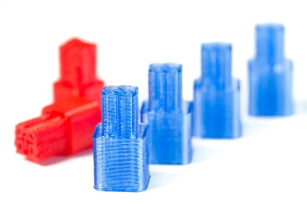
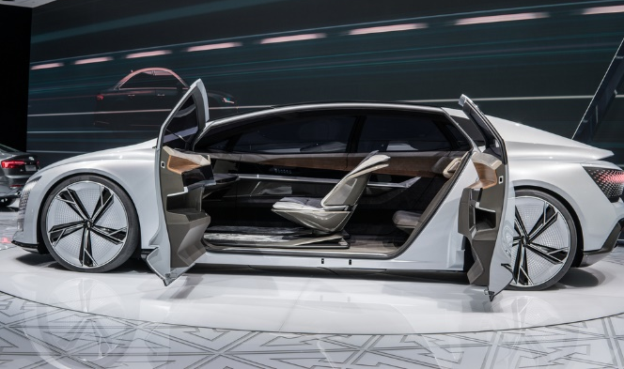
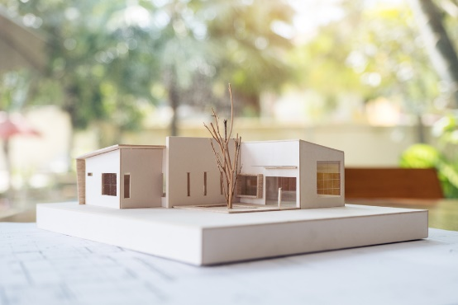

Task 2
What might be the disadvantages of rapid prototyping?

Task 3
Select two of the products from the photos below and list any design considerations needed to be thought through before prototyping a new design for the product begins.
Explain your answers and refer to at least one of the types of prototype mentioned below.
- Visual prototype
- Proof of concept prototype
- Presentation prototype
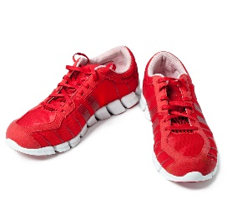 |  | 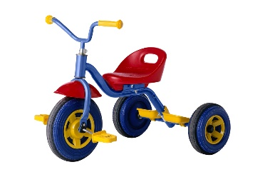 |  | 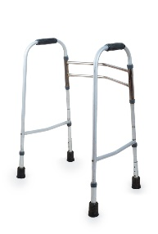 |  | 