Name: Class:

Task 1
Match the Human Centred Design processes listed below to their definitions.
Ethnographic interviews |  | The collection of data through observing users without directly engaging with them
Fly on the wall observations |  | A planned discussion with a gathering of deliberately selected people to elicit consumer perceptions about a particular product or service
Personas |  | Physically acting out what happens when users interact with products or services to prompt more intuitive response
Day-in-the-life |  | Informal interviews that take place in situ to help understand behaviours
Role play |  | Unobtrusively gather information by looking and listening with direct participation and interference with people being observed
Focus groups |  | Fictional characters based on user research to focus a designer on the needs of their target market

Task 2
1. Describe what a circular economy approach to designing involves.

2. Using a circular economy approach, analyse the following products and suggest how they could be developed to be more sustainable.


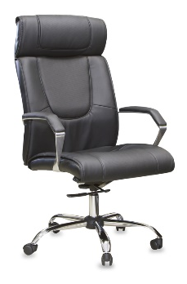

Plenary Task
Crossrail’s Elizabeth line is one of the biggest civil engineering projects ever undertaken in the UK and will cost around £15 billion. It is running 2 years’ late as of 2019.
Watch the Link video Crossrail Elizabeth line [2m50s].
The design of a new train carriages requires collaboration between many different experts. List the different jobs titles or rolls that these experts would be doing collaboratively and go on to explain the purpose of their involvement in the delivery of this major UK project.
Job Title | Reason to be included in the design process

