Name: Class:

Task 1
Products continuously undergo performance evaluations so that designers and manufacturers can identify potential improvements and suggest modifications.
For each of the products shown in the table below, complete a product performance evaluation and describe any resulting modifications that were made in the recent version.
An example has been started for you.
Original | Product Performance Evaluation | Resulting Modification | Recent
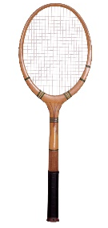 | - Heavy wooden frame  - Small surface area to hit the ball with | - Lightweight carbon fibre frame  - Larger surface area to hit the ball with | 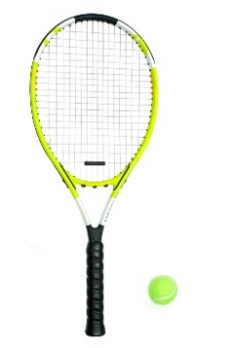
 |  |  | 
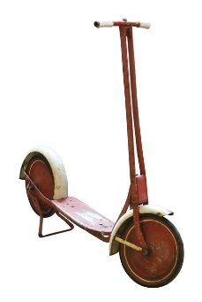 |  |  | 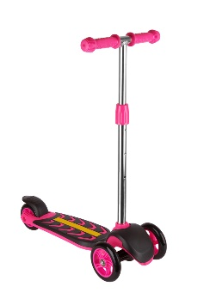
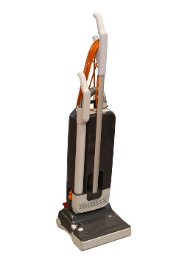 |  |  | 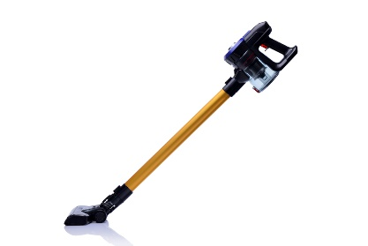

Task 2
(a) Give three reasons why companies manufacturing power tools may choose to undergo testing in an anechoic chamber to analyses sound emissions.
Reason 1:

Reason 2:

Reason 3:

(b) Explain the process of, and reasons for wind tunnel testing.

Task 3
Describe the different testing processes that might be used to test a child’s soft toy.
