Name: Class:

Task 1
For each testing method, identify if it is a destructive or non-destructive test, and describe what the test entails. An example has been done for you.
Test | Destructive/  Non-destructive | Definition
Ultrasonic  test | Non-destructive | Utilises sound waves to detect cracks and defects in parts and materials. Can be used to determine a materials thickness.
Drop
test
Radiographic test
Visual
test
Tension
test
Task 2
1. List and justify three factors to consider when planning a focus group feedback session.

2. Study the image below.
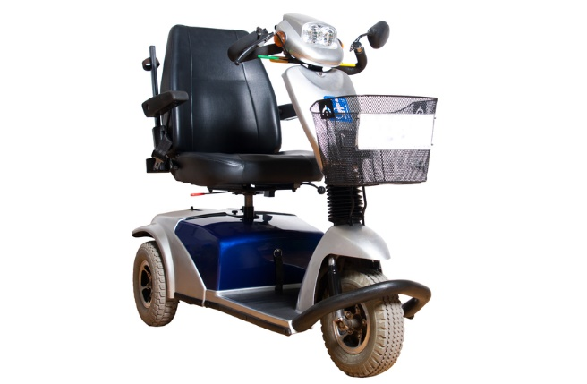
Mobility scooter designed with user group feedback
Explain why client feedback is important throughout the design process.

Task 3
1. List two different testing methods that could be used to develop a design
for a new mobility scooter.
Testing method 1:

Testing method 2:

2. Describe how one of the testing methods mentioned above can lead to possible modifications.

3. Explain how you could analyse data gathered from a focus group and wider market research.

