Name: Class: Mark:

1. Which one of the following is not an example of third-party testing? [1]
⬨ Expert advice
⬨ Non-destructive testing
⬨ Client feedback
⬨ Designer testing
2. Explain the benefits of destructive testing on vehicles. [4]

3. Study the image of the rollercoaster.

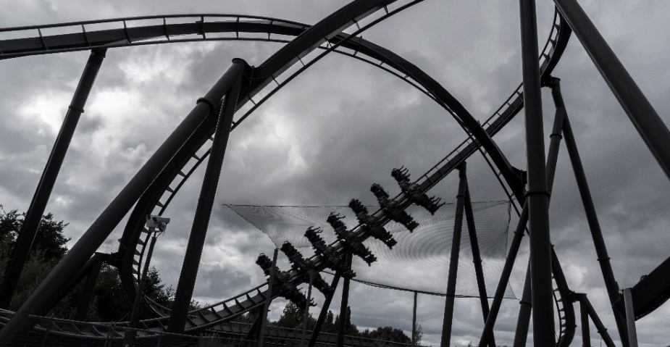
The Swarm rollercoaster at Thorpe Park is a steel wing coaster that opened in 2012. The 775m long ride takes people on a one minute twenty-five second ride that reaches a maximum height of 39m and a top speed of 57 miles per hour, exerting a maximum force of 4.5 g on passengers.
(a) Name two methods of testing that could be used to ensure safety of passengers. [2]
Method 1:
Method 2:

(b) Describe and explain how one of the testing methods mentioned in question 3 (a) could result in modifications to the design. [4]

(c) Evaluate the use of non-destructive testing in rollercoaster design and maintenance [9]

[Total 20 marks]

