Name: Class:

Task 1
For each piece of workshop equipment shown below, describe the potential hazards and list the prevention methods that should be taken as a result.
Equipment | Potential Hazard | Prevention Method
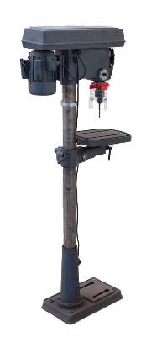



Task 2
Describe the steps you would take to ensure the table below was suitable for being
batch produced.


Task 3
Common causes of workplace accidents include lifting, fatigue, poor lighting, hazardous materials, trips and falls.
Explain how the implementation of the Health and Safety at Work Act 1974 helps remove the common causes of workplace accidents.

