Name: Class:

Task 1
For each piece of measuring and marking out equipment shown below, name the tool
and explain how it is used to ensure accuracy in manufacture.
Equipment | Name | Use
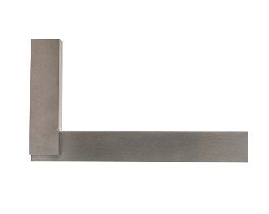
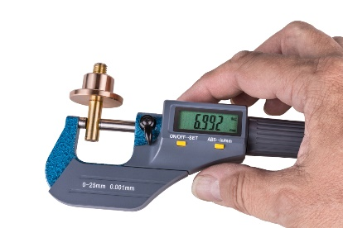

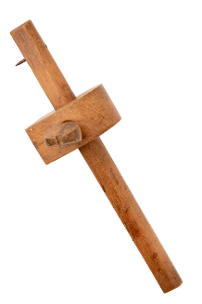
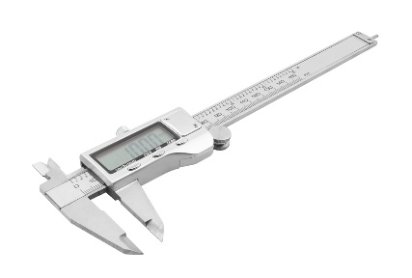
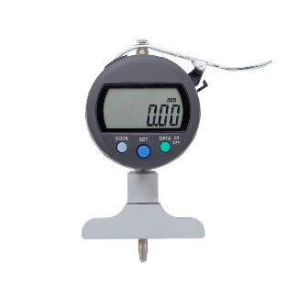
Task 2
Give two methods in which accuracy can be increased in batch production.
Method 1:

Method 2:

If a tolerance is given as 198mm ±0.02mm, what is the highest and lowest
value the dimension can be?

Evaluate the use of go no-go gauges in commercial production.

