Name: Class:

Task 1
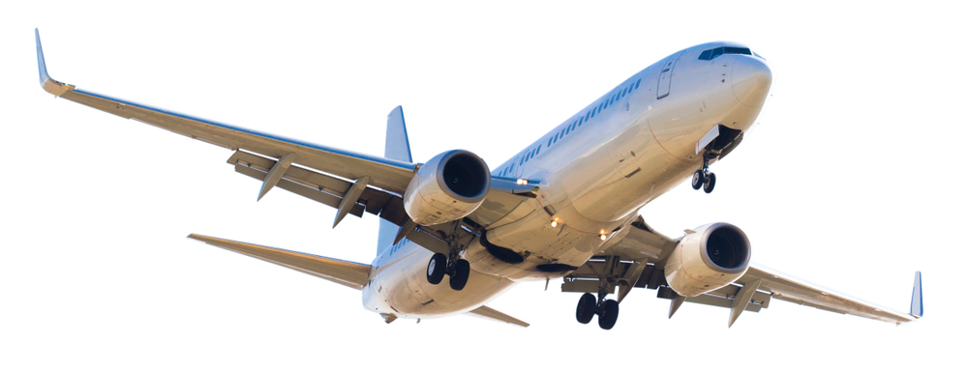
Consider the carbon footprint of a modern passage aircraft, which is said to produce nearly 30 times more CO₂ than a high-speed electric train.
In 2017 a national newspaper took five aircraft from five different airlines flying both short and long haul and worked out that in one week, those five planes flew a total of 195,543 miles which is equivalent to approximately eight times around the world. One well known budget airline flew 46 flights to 19 destinations, clocking up 28,326 miles in one week.
As manufacturers like Boeing and Airbus produce new aircraft for the commercial market, suggest and explain three areas of sustainability they should be focusing on.

Task 2
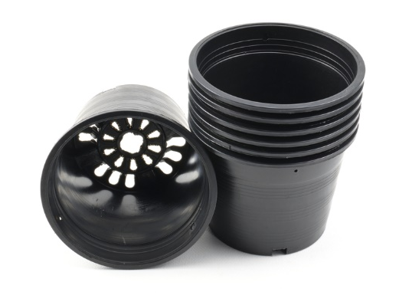
Case study: POSIpot by Edible Culture
Black pots are a problem for recycling centres because the optical scanners that sort plastics for recycling cannot consistently detect them. As a result, these single use plastic pots frequently end up in landfill.
Horticulturalists at garden centre Edible Culture, have developed a simple, flat packed flowerpot made from a recycled, unbleached card which, when assembled, forms a ‘compostable transportation sleeve’ held together with a flat wooden stick which doubles as a label.
When a customer purchases a plant, it is transferred from the reused plastic plant pot it was grown in into a POSIpot, free of charge, for transportation home.
Suggest three advantages of this scheme to:
(a) The consumer

(b) The garden centre/seller

Suggest one way in which the garden centre could successfully recycle broken plastic pots.

Suggest one alternative material or solution for each of the use plastic products below and explain your choice.
(a) Disposable Polystyrene (PS) cutlery

(b) Expanded polystyrene (EPS) packaging

(c) HDPE detergent bottles

For more information visit: https://edibleculture.co.uk/ and https://posipot.co.uk/

