Name: Class:

Task 1 The circular economy
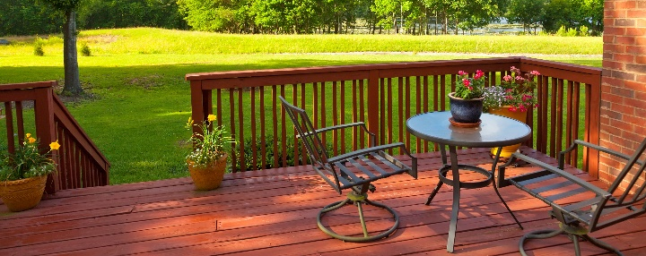
Homeowners are increasingly taking advantage of what room they have outside their house to extend their living space. One popular method of achieving this is by installing decking to create a hardy, all weather surface.
Discuss the two decking options below focusing on how they fit into a circular economy.
Natural timber decking

Composite decking

Task 2 Sustainable packaging
Watch the short Link video on sustainable packaging [3m19s].
Using the video clip as inspirations, suggest as many alternative packaging materials or solutions as you can for the following existing products.
1. Yoghurt pots.

2. Flat screen television packaging.

3. Dry food goods such as rice, pasta and cereal.

4. Seedlings sold at garden centres.

