Name: Class:

Task 1 Life Cycle Assessment
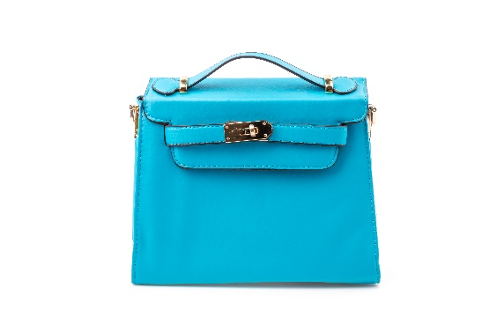

1. Conduct a Life Cycle Assessment on a polyurethane (PU) leather effect handbag like the one on the right. Using the headings provided, break down the environmental impact of the product at each stage of its life.
Extraction:

Production:

Distribution:

In use:

End of life:

2. What could you do to improve the environmental impact of a polyurethane leather effect handbag?

3. What new material is being used to provide an alternative solution?

4. Describe how the you might dissuade consumers from purchasing handbags made from laminated PU leather.

Task 2
In a time of change how we power our homes, vehicles and technology is one of the most pertinent issues however, companies building new renewable energy sources do not always meet with immediate approval from the general public.
Discuss the reasons why the installation of solar and wind farms or tidal barrages may be seen by some as controversial and may have planning permission held up or turned down. Why has it taken so long for renewable energy systems to be seen as viable options?

