Name: Class:

Task 1

A company making plastic ball chuckers has noticed their profit margins have been reducing over the past couple of years and wish to find ways to make savings. As part of an efficiency audit they have compiled a list of practices where they think they may be able to make changes to increase efficiency.
Study the list below and suggest a change for each point which will increase the efficiency of the company and potentially see their profit margins increase over time.
Materials and purchase:
- The chuckers are made from HDPE plastic granules which are ordered from China. 1,600 kg of granules are ordered twice a year (400kg each of four colours green, blue, red and purple).

- Shipping to wholesalers takes 1 week from time of order and is free of charge with a minimum order of 1,000kg.

Manufacture:
- Chuckers are injection moulded. Each chucker requires 300g of granules and a batch of approximately 150 chuckers of each colour is produced per month.

- The company owns four injection moulding machines (one for each colour) however energy costs dictate that the machines are not run simultaneously.

- Granules are fed into the hopper as required.

- Any flashing or waste resulting from the process is sent away for recycling which costs the company £1,000 a year.

Sales:
- Sales are both direct to customers online and through five retail outlets. Online sales account for 78% of all sales. The product costs £0.99 to manufacture retails online for £4.50 (postage is included at £0.90 per chucker) and the wholesale price to retailers is £2.00.

- Red is the most popular colour with blue and green second. Purple chuckers rarely sell and there is surplus stock.

Task 2
Study the products below. For each product, discuss how you would plan for accuracy and efficiency. Cover areas including waste management, time management and production methods for different scales of production.
Folded paperboard noodle carton | Acrylic menu frame
 | 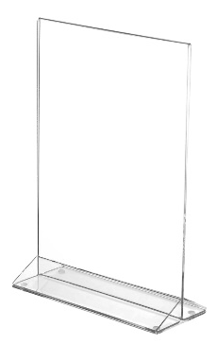
Planning for accuracy and efficiency: | Planning for accuracy and efficiency:
Aluminium coat hook | Plywood crate
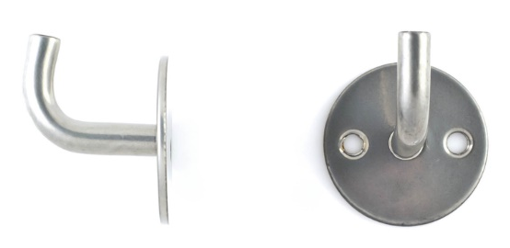 | 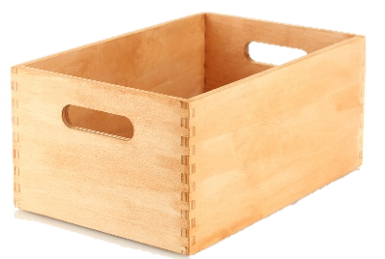
Planning for accuracy and efficiency: | Planning for accuracy and efficiency:

