Name: Class:

Task 1
Study the pictures of a ballpoint pen and the parts list and manufacturing activities below.
Parts List
Item | Part | Material | 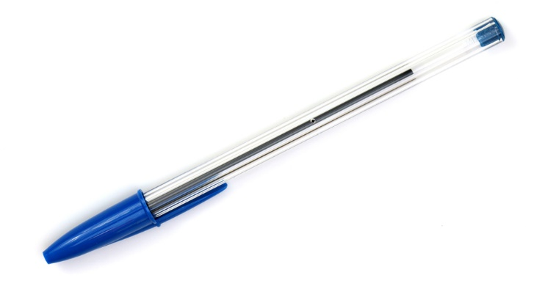
1 | Barrel | Polystyrene
2 | End cap | Polypropylene
3 | Ink tube | Polypropylene
4 | Tip | Brass
5 | Ball | Tungsten carbide

Manufacturing Activities
 | Activity | Time taken
1 | Manufacture barrel | 18 seconds
2 | Manufacture end cap | 16 seconds
3 | Manufacture ink tube | 18 seconds
4 | Manufacture tip | 18 seconds
5 | Manufacture ball | 6 seconds
6 | Assemble tip, ball and tube subassembly | 4 seconds
7 | Assemble barrel, end cap and tip/ball/tube subassembly | 4 seconds
8 | Test function of subassembly | 4 seconds
9 | Test complete pen | 4 seconds

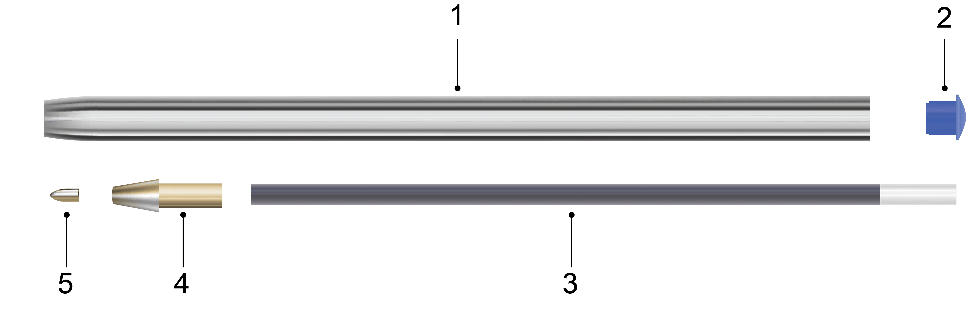
The pen has five individual components. There are nine clear activities involved in the manufacturing of the pen: five manufacturing processes, two assembly processes and two quality control (QC) checks. In the manufacturing activities table above you can see how long each activity takes.
Use the space below to plan the manufacturing processes of the pen by arranging the nine activities in a flowchart, Gantt chart or other visual planning tool.
At first, you may wish to use small pieces of paper or post-it notes which can be easily rearranged. Add arrows or number if appropriate to indicate the order of the operations.

Task 2
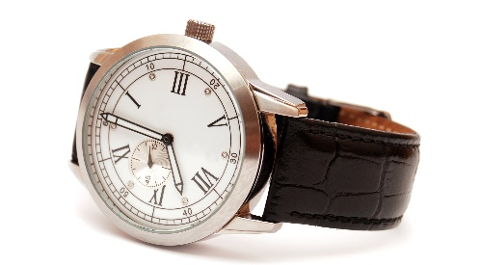

A company making watches uses Six Sigma methodology to produce their products. The products include outsourced components including batteries, watch straps and glass lenses. What problems could arise preventing them from meeting Six Sigma quality?

Using the five phases Define – Measure – Analyse – Improve – Control (DMAIC), outline a plan to help the company overcome these problems.

Task 3
Name two different precision measuring devices which are commonly used to check for dimensional accuracy and explain their use.

