Name: Class: Mark:

1. The Mobius Loop and the Green Dot symbols are often confused with each other.
Explain the differences between them. [4]

2. The main standards agency for the United Kingdom created the Kitemark logo in 1903, which was one of the world’s first quality marks.
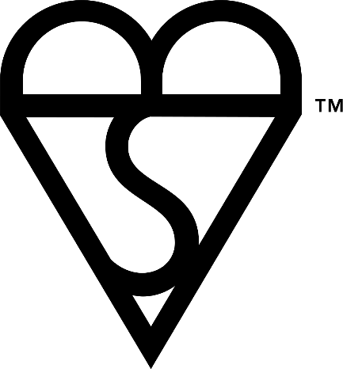
(a) Which three letters have been combined to produce it and what words do they represent? [3]

3. Explain the categories and types of products that are covered by the WEEE Directive
and include at least one example. [3]

4. With reference to a specific product, explain what is meant by the term ‘ecolabelling’. [4]

5. Evaluate the impact of legislation on the design of electrical or electronic products
using examples of specific directives and products to support your response, [10]

[Total 24 marks]

