Name: Class:

Task 1
ISO 9001:2015 is the certification of a standard that states that a company must meet certain ‘Quality management systems-Requirements’.
Taking into consideration the seven quality management principles of ISO 9000, use the headings below to suggest ways in which a company might seek to improve the quality of its practice, products and services to ensure it meets the requirements for ISO 9001 certification.
Leadership

Improvement

Customer focus

Process approach

Engagement of people

Relationship management

Evidence-based decision making

Task 2
The following symbols can be found on many commonly used products. If you have any of the following products to hand, look for symbols on them: electrical/electronic products, laptop power supplies, lightbulb packaging, batteries, plastic bottles and food packaging, plastic bags and wrappers, aluminium drinks cans and cardboard packaging. The symbols relate to energy use, energy efficiency, recycling, disposal or safety.
Working in small groups, discuss the meaning of the different symbols. Try to find out:
- What their meanings are
- What types of products or materials they relate to
- Which organisations they represent
- In which countries or regions, they apply

 |  | 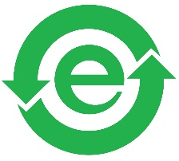 | 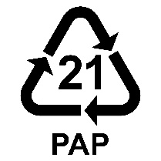
1. | 2. | 3. | 4.
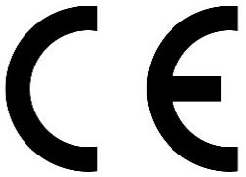 |  | 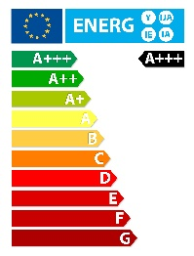 | 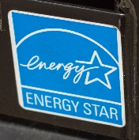
5. | 6. | 7. | 8.

