Name: Class:

Starter activity
Use the samples of paper and boards provided to analyse and note any characteristics in the table provided. Add the paper type being analysed to each column header.
Paper or board Characteristic | Sample 1  Type: | Sample 2  Type: | Sample 3  Type:
Whiteness

Opacity

Strength

Absorbency

Surface finish

Predicted cost
High – mid - low

Task 1
Use the samples of paper and boards provided. Add the characteristic that you want to comment on in the left column and then list the types and levels of processing that may
have taken place during the manufacture of the specific paper or board.
You can use any of characteristics from task one and any others you may have covered through the lesson. Add the paper type being analysed to each column header.

Paper or board Characteristic | Sample 1  Type: | Sample 2  Type: | Sample 3  Type:

Task 2
Study the image of the point of sales display box.
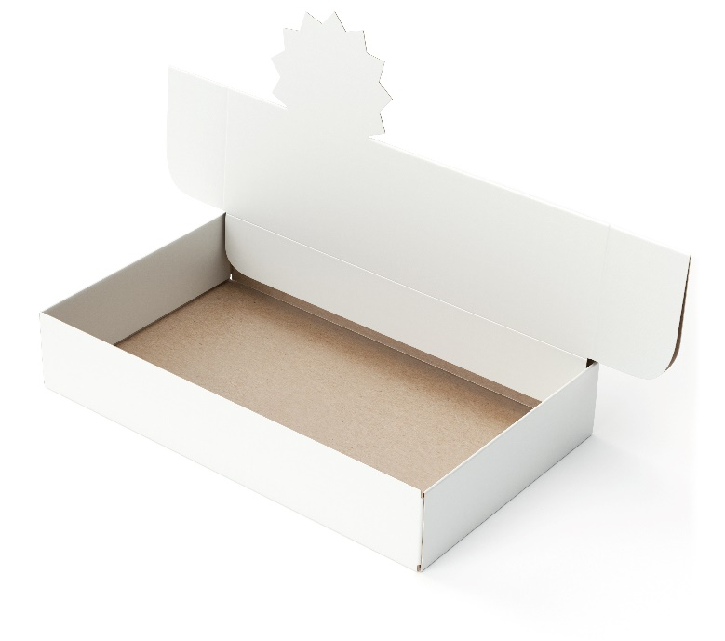
The outline for the die cut net to make the box has been added below. Add dotted lines to the net where you think the crease rule would be pressed to facilitate easy folding of the box.
