Name: Class: Mark:

1. Name three sources of cellulose fibre, other than wood, that are used to make
papers and boards. [3]

2. Give the other four main characteristics that papers and boards are categorised by. [4]

Cost – strength -

3. This question is about the process of making paper from cellulose fibres.

(a) What is the name of the natural compound found in wood that needs to be
removed from the cellulose fibres to make paper pulp? [1]

(b) Name a chemical that is used to remove the compound mentioned in 3(a)? [1]

(c) Name two other additives, other than water, that can be used during the paper making process. [2]

(d) Describe how the absorbency of paper is reduced. [3]

4. Study the diagram below and label the parts a, b and c. [3]

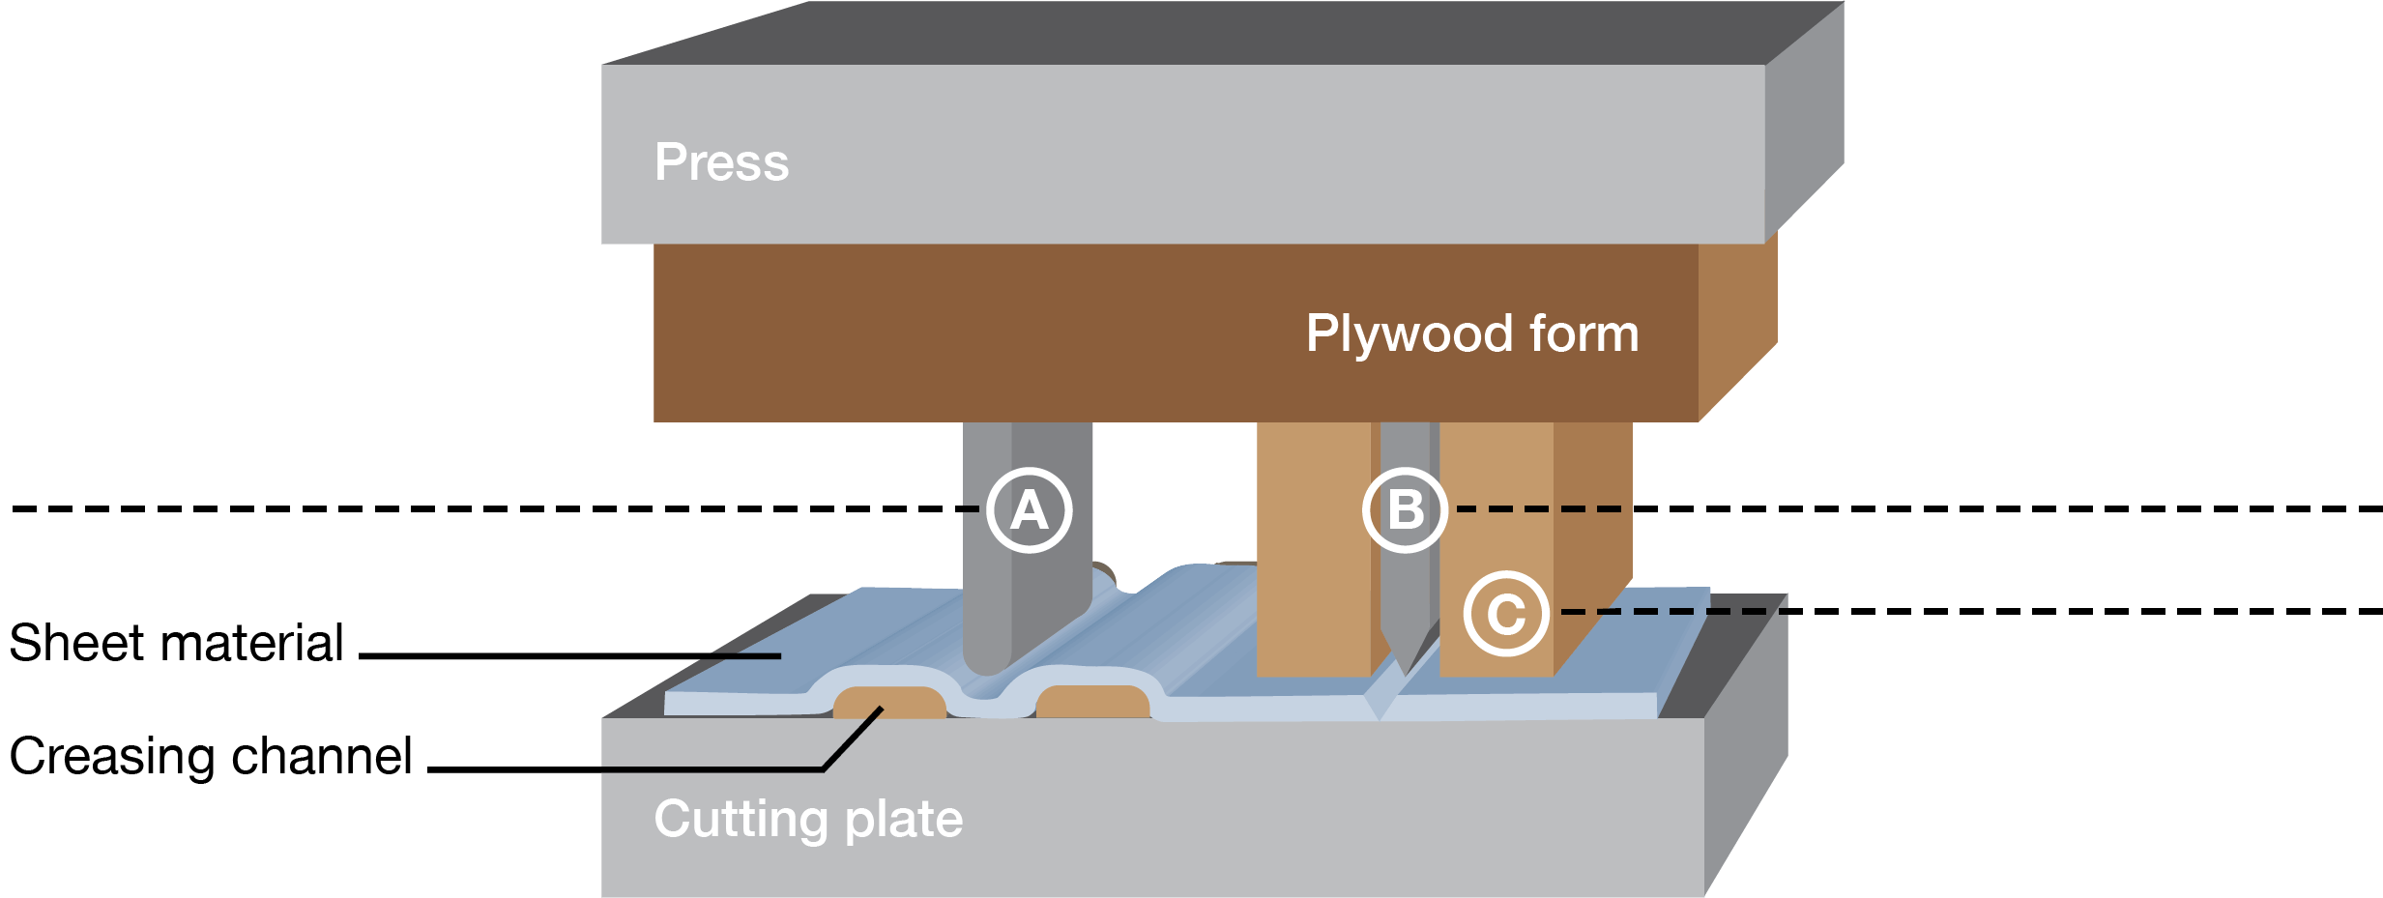

5. Explain the process of making A4 photocopy paper from tree to finished sheet. [8]

Continue on a separate sheet if required.

[Total 25 marks]

