Name: Class:

Task 1
A graphic designer has created a promotional A1 sized poster (594 x 841mm) for a live concert at the local arena. She wants to have 750 copies printed in full colour. The commercial printer uses SRA size paper for the print run. The dimensions for this series are given in the picture below.
- Why does the printer not use A series paper for printing the posters?

- What are the dimensions for the correct SRA size paper to be able to print
the A series posters?

- Calculate the area of any potential waste per sheet.

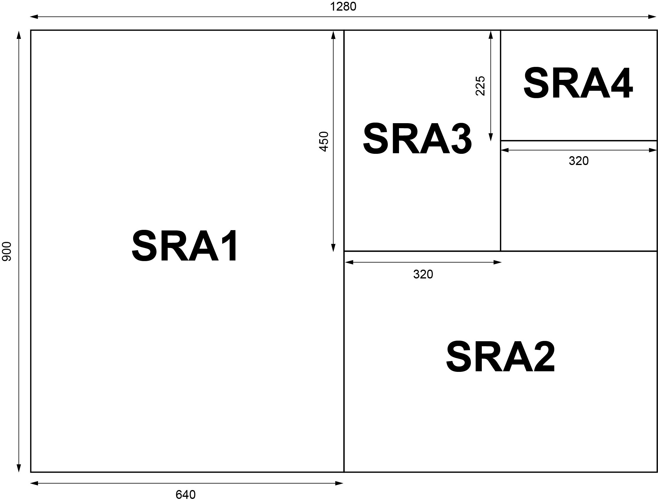
Task 2
Using notes and sketches create an informative diagram showing the structure of the following board types:
Single wall corrugated cardboard
Tetra-Pak®

