Worksheet 2 Adders and D-type flip-flops

Task 1

1. (a) Complete the truth tables below for the AND gate and the XOR gate.
Input A | Input B | A · B
0 | 0
0 | 1
1 | 0
1 | 1

Input A | Input B | A ⊕ B
0 | 0
0 | 1
1 | 0
1 | 1

AND gate XOR gate

(b) Draw a circuit corresponding to S = A ⊕ B

(c) Draw a circuit corresponding to C = A · B

(d) Combine these two circuits to form a half-adder which has inputs A and B out outputs S and C.

(e) What do the outputs S and C represent?

2. (a) Below is a logic circuit for a full adder.
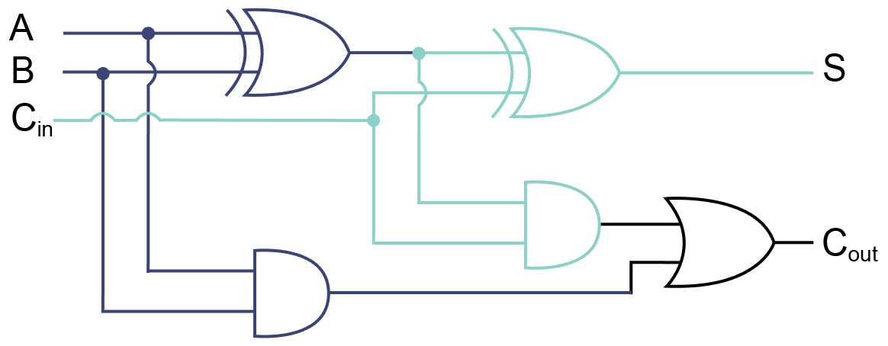
What are the inputs to a full adder?

Write the Boolean expressions for S and C_{out} representing this logic circuit.

(b) Show the outputs S₀, S₁, S₂, S₃, C₁, C₂, C₃ from the following concatenated adders.

 | ^{C}₃ | ^{C}₂ | ^{C}₁ | ^{C}₀
 | 0 ^{A}₃ | 1 ^{A}₂ | 1 ^{A}₁ | 1^{A}₀
+ | 0 ^{B}₃ | 1 ^{B}₂ | 0 ^{B}₁ | 0 ^{B}₀
= | ^{S}₃ | ^{S}₂ | ^{S}₁ | ^{S}₀

3. Complete the following truth table for a full adder.
A |  | B |  | C_{in} |  | S | C_{out}
0 | + | 0 | + | 0 | =
0 | + | 0 | + | 1 | =
0 | + | 1 | + | 0 | =
0 | + | 1 | + | 1 | =
1 | + | 0 | + | 0 | =
1 | + | 0 | + | 1 | =
1 | + | 1 | + | 0 | =
1 | + | 1 | + | 1 | =

Task 2
5. (a) What are the characteristics of an edge-triggered D-type flip flop?

(b) What is a D-type flip flop used for?

(c) Draw the flip flop’s output Q on the graph.
