Homework 2 Adders and D-type flip-flops

1. (a) What is a half adder? [3]

(b) Complete the diagram below to construct a half adder circuit. [2]
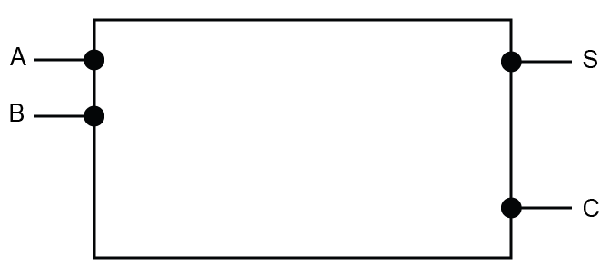
(c) Draw the truth table for the half adder, which has inputs A and B and
outputs S and C. [2]
A |  | B |  | S | C
0 | + | 0 | =
0 | + | 1 | =
1 | + | 0 | =
1 | + | 1 | =

(d) What are the inputs to a full adder? [2]

(e) Show the outputs S₀, S₁, S₂, S₃, C₁, C₂, C₃ from the following 4-bit adder. [4]
 | ^{C}₃ | ^{C}₂ | ^{C}₁ | 0 ^{C}₀
 | 1 ^{A}₃ | 0 ^{A}₂ | 1 ^{A}₁ | 1 ^{A}₀
+ | 0 ^{B}₃ | 0 ^{B}₂ | 1 ^{B}₁ | 1 ^{B}₀
= | ^{S}₃ | ^{S}₂ | ^{S}₁ | ^{S}₀

2. (a) What is an edge-triggered D type flip-flop? [3]

(b) Draw the flip flop’s output Q on the graph. [4]

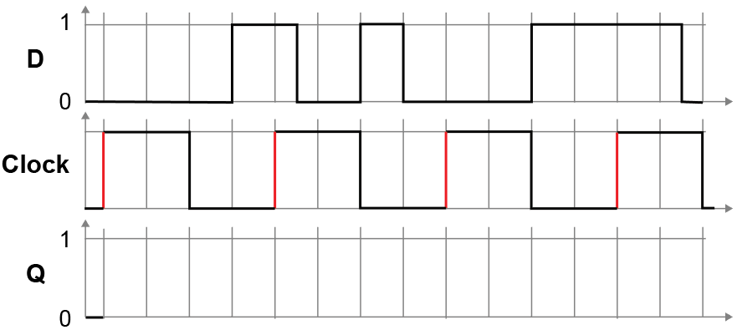
[Total 20 marks]

