Name: Class: Mark:

1. Explain what is meant by the term inclusive design. [2]

2. Mobile phones are modified, and features added to make them more suitable for the elderly.
(a) Give two features of a phone’s hardware that might be modified / added. [2]

(b) Give two features of a phone’s software that might be modified / added. [2]

3. Suggest four ways in which lift control panels, such as the one pictured below could
be made more suitable for the following user groups: [8]
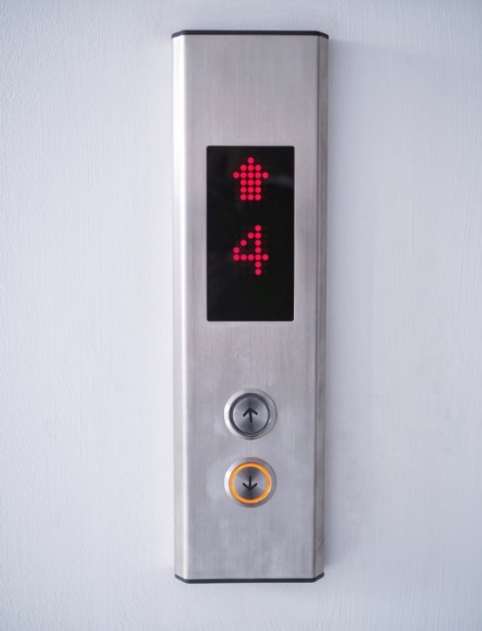
(a) Wheelchair users

(b) Those with visual impairments

(c) Those with hearing impairments

(d) Elderly people

4. Discuss ways car interiors and controls can be designed to be inclusive. Consider
the benefits to a range of user groups in your discussion. [6]

[Total 20 marks]

