Name: Class:

Starter
Name as many temporary and permanent methods of adhesive or fixing which can be used on paper and board on the diagrams below. Some examples have been done for you.
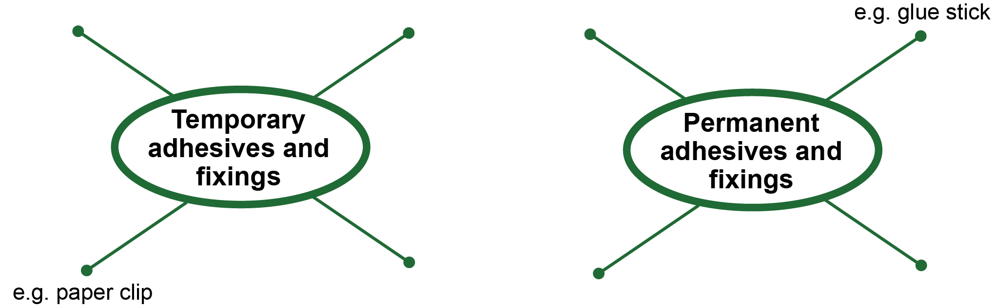

Task 1
Study the products below and suggest a suitable adhesive or fixing for each.
Explain your answers.
 |  | 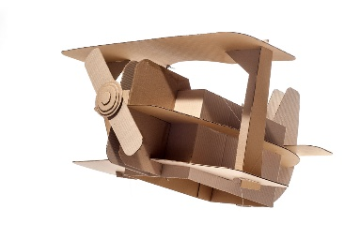
Sticking photos in an album | Sealing a corrugated cardboard box | Assembling a model  card plane
Task 2
Study grid below which shows some common fixing components. Give an advantage, a disadvantage and a common application for each.
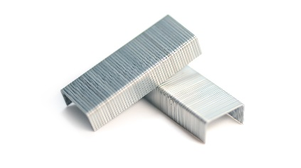 | 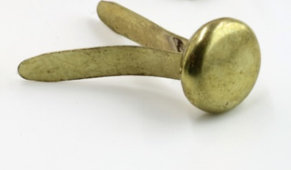 | 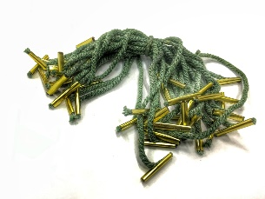
Staples | Paper fasteners | Treasury tags
Advantage:  Disadvantage:  Application: | Advantage:  Disadvantage:  Application: | Advantage:  Disadvantage:  Application:
 | 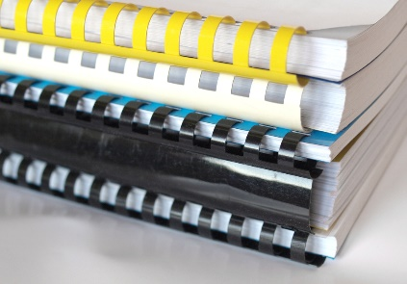 | 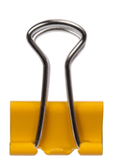
Sticky pads | Comb binding | Bulldog clip
Advantage:  Disadvantage:  Application: | Advantage:  Disadvantage:  Application: | Advantage:  Disadvantage:  Application:

Task 3
Design a range of different jigs that you could you make in the workshop to perform the following tasks on a batch of 200 products:
- Adding a repeated motif to a product
- Creating creases on net developments
- Bending/folding a batch of leaflets
- Cut a perfect quarter circle in paper
